What is Project Management?

Project management is the use of specific knowledge, skills, tools and techniques to deliver something of value to people. The development of software for an improved business process, the construction of a building, the relief effort after a natural disaster, the expansion of sales into a new geographic market—these are all examples of projects.

All projects are a temporary effort to create value through a unique product, service or result. All projects have a beginning and an end. They have a team, a budget, a schedule and a set of expectations the team needs to meet. Each project is unique and differs from routine operations—the ongoing activities of an organization—because projects reach a conclusion once the goal is achieved.

The changing nature of work due to technological advances, globalization and other factors means that, increasingly, work is organized around projects with teams being brought together based on the skills needed for specific tasks.

Leading these projects are [Project Professionals](https://www.pmi.org/about/learn-about-pmi/who-are-project-managers)—people who either intentionally or by circumstance are asked to ensure that a project team meets its goals. Project professionals use many different tools, techniques and approaches to meet the needs of a project.

Some projects are needed to quickly resolve problems, with an understanding that improvements will be made over a period of time. Other projects have a longer duration and/or produce a product or other outcome that will not need major improvements outside of projected maintenance, such as a highway.

Still others will be a mix of both of these types of projects. Project professionals use a variety of skills and knowledge to engage and motivate others to reach a project’s goals. Project professionals are critical to the success of projects and are highly sought after to help organizations achieve their goals.

For a deeper understanding of what it’s like to manage a project, [try Kickoff from PMI](https://www.pmi.org/kickoff), a free, 45-minute digital course and toolkit that guides you through the basics of project management.

Who is PMI?

As the world’s leading authority on project management, PMI empowers people to make ideas a reality. Through global advocacy, networking, collaboration, research, and education, PMI prepares organizations and individuals to work smarter in an ever-changing and dynamic world.

Building on a proud legacy dating to 1969, PMI is a “for-purpose” organization working in nearly every country around the world to advance careers, strengthen organizational success, and enable changemakers with new skills and ways of working to maximize their impact.

What is project management?

Project management is defined as the process of steering a project from the start through its lifecycle. The main objective of project management is to complete a project within the established goals of time, budget, and quality. Projects have life cycles since they aren’t intended to last forever.

A project management life cycle starts when the project is initiated and ends when the project is either completed or terminated in one way or another.

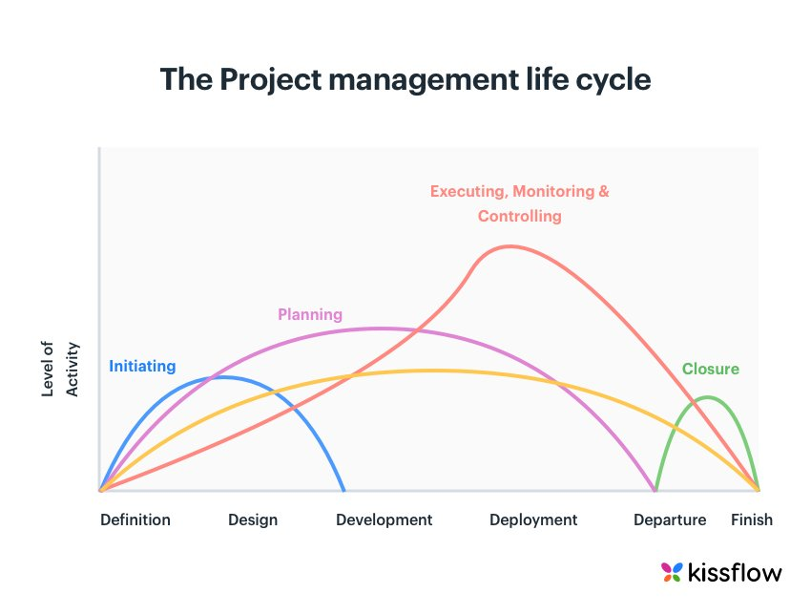At the end of each phase, there is a decision point where [stakeholders](https://kissflow.com/project/project-stakeholder-management/) decide whether or not to complete the project or terminate it and cut losses.

## **Why is it important to manage projects?**

According to a survey by the Project Management Institute ([PMI](https://www.pmi.org/)), only 58% of organizations realize the actual [importance of project management](https://kissflow.com/project/importance-of-project-management/) and how it allows them to effectively tackle the issues they face.

[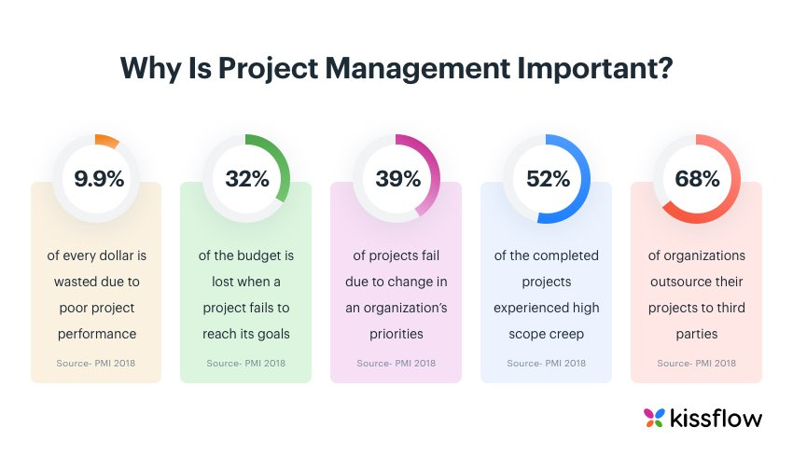](https://kissflow.com/wp-content/uploads/2019/07/why-is-project-management-important.jpg)

Apart from stimulating productivity, improving [project transparency](https://kissflow.com/project/how-to-improve-project-transparency/), and providing a clear vision to the team, project management can bring the following advantages to the table:

Effective communication

Efficient resource management

Improved customer satisfaction

Flexibility and higher risk tolerance

Improved team morale

Better quality of the output

Retrospective learning

What if all projects were handled on the fly? No plans, no organization, none of that. We just brief the team on what needs to be done and they jump straight in. Like baking a cake. You wouldn’t draw up an action plan to bake one, no?

Unfortunately, most [projects](https://kissflow.com/project/what-is-a-project/) are complex and multi-faceted, requiring careful planning, organizing, and monitoring.

Only by having a structured approach, supporting processes, and clearly defined [roles and responsibilities for project managers](https://kissflow.com/project/roles-and-responsibilities-of-project-manager/), they can deliver stellar results while staying within the [project constraints](https://kissflow.com/project/project-management-constraints/). However, despite global recognition and the obvious benefits and advantages of project management, the field remains underappreciated.

[](https://kissflow.com/wp-content/uploads/2019/07/why-is-project-management-important.jpg)

According to a survey by the Project Management Institute ([PMI](https://www.pmi.org/)), only 58% of organizations realize the actual importance of project management and how it allows them to effectively tackle the issues they face. Similarly, the percentage of companies that use standardized [project management practices](https://kissflow.com/project/project-management-best-practices/) across the board is only 23%.

## Why is project management important – 10 main benefits

A clear understanding of [project management](https://kissflow.com/project/project-management-basics/) and having an effective project management system can do wonders for your organization. Project management is important because it sets your project from being out of the scope. Apart from stimulating productivity, improving [project transparency](https://kissflow.com/project/how-to-improve-project-transparency/), and providing a clear vision to the team, these 10 benefits of project management listed below can bring the following advantages to the table.

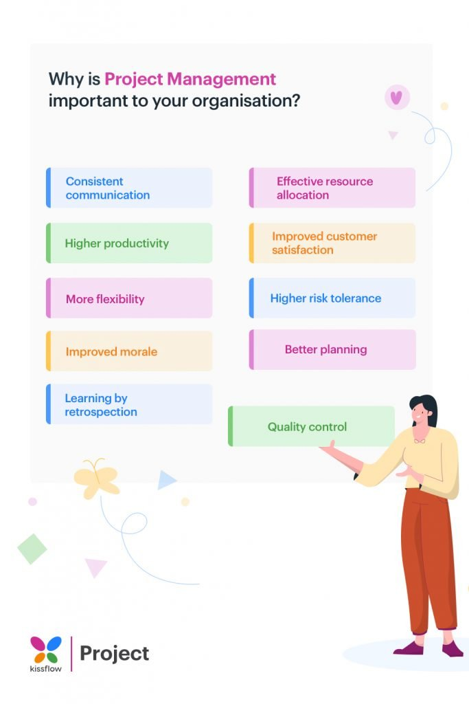

## 1. Consistent communication:

## No [project plan](https://kissflow.com/project/steps-to-create-successful-project-plan/) is complete without a solid communication structure. [Communication in project management](https://kissflow.com/project/communication-in-project-management/) is an extremely important aspect that can have a significant effect on the performance of a team. A study analyzed the reasons for project failure in the UK’s finance sector and found that communication breakdown was the main cause of failure for 57% of the studied projects.

## Project managers must ensure that the whole team shares a collective end-goal and work together to achieve it. The overall efficiency and productivity of the entire team get significantly improved which leads to other benefits as well.

## 2. Effective resource allocation:

## The biggest resource any project managers have at their disposal is the team members. The [project team](https://kissflow.com/project/project-team-management/) consists of people of different backgrounds and departments and they might have other commitments. Through proper project planning, you can ensure that they are available when needed.

## Similarly, other resources like the budget, tools, machinery, and others can be arranged effectively to [avoid project delays](https://kissflow.com/project/how-to-avoid-project-delays/) during the execution. By properly allocating each resource in the beginning, you can also [monitor the phases](https://kissflow.com/project/project-monitoring-and-controlling/) that are more demanding and prepare accordingly.

## By figuring out a smarter and efficient direction, you can ensure that each [prioritized task](https://kissflow.com/project/team/how-to-prioritize-project-tasks/) is optimized to give you maximum output at the lowest cost.

## 3. Higher productivity:

## The field of project management is interconnected with being productive. Through proper utilization of resources and having an efficient system in place, a project team can easily get more work done in a shorter amount of time and increase productivity.

## 4. Improved customer satisfaction:

## Retaining clients is considered more important than acquiring new ones and a guaranteed way of doing it is by offering unparalleled services. An effective set of operations that focuses on quality and efficiency, would naturally leave the clients feeling satisfied. This means that they would return with more business in the future.

A satisfied client would also refer your organization to other potential customers, which means free marketing for you. This can be an extremely effective marketing strategy for businesses.

## 5. More flexibility:

As you increase your customer base, your organization would be able to gain more capital which it can use to expand the business and hire new talent.

## 6. Higher risk tolerance:

## Proper planning means that you are ready for potential ‘what-if’ scenarios that may occur. This means that you are somewhat prepared to tackle any unforeseen occurrences that may negatively impact your project.

## 7. Improved morale:

## With continuous success and effective performance, your team gains more confidence. Effective project managers inspire their team by incentivizing and regularly rewarding top performers to keep everyone motivated.

## 8. Better planning

## Planning a project effectively right from the start lays the foundation for a successful project. Project management includes a phase for a project plan where you can clearly define

## It keeps your team from slowing down and avoids unnecessary bureaucracy.

## While it may be tempting to dive straight in, project management helps you in the longer run. With a solid project plan, you can ensure that you have an agreement with the client’s requirements, get all [project stakeholders](https://kissflow.com/project/project-stakeholder-management/) on the same page, and flag risks in advance.

## 9. Quality control

## Most project managers are under enormous pressure to complete the project on time. When deadlines are missed, [project schedules](https://kissflow.com/project/basics-of-project-scheduling/) get tightened, work is rushed, and corners are cut, resulting in poor quality work.

## Methodologies like [Agile](https://kissflow.com/project/agile/agile-project-management-methodology/) ensure the quality and applicability of the delivered product by creating a separate phase for examining and testing at every step. Proper project management also gives you control over the timelines and resources.

## 10. Learning by retrospection

## As a project manager, you can’t afford to make the same mistake twice. It’s also key to do more of what went right and less of what went wrong. And, projects generate a tremendous amount of knowledge.

## Almost every [project management methodology](https://kissflow.com/project/project-management-methodologies-and-frameworks/) includes a retrospective stage at the end of the project to facilitate this. Frameworks like [Scrum](https://kissflow.com/project/agile/scrum-methodology/) include periodical retrospection so you can learn from what went wrong throughout the course of the project.

## Properly recorded documentation allows you to keep track of all activities, enabling the team to learn from successes and [project failures](https://kissflow.com/project/why-projects-fail/). The learnings from a project can be applied to all future projects. It’s also a great tool to estimate costs and project timelines.

## **How does project management come into existence?**

## The history of project management is that it has been around for as long as humans have existed–from the invention of the wheel to the construction of the Giza Pyramids to the development of the device you’re reading this on. All these “projects” required planning, had specific people to oversee them, a sponsor, and people working on them. We just didn’t call them [projects](https://kissflow.com/project/what-is-a-project/).

## [Project constraints](https://kissflow.com/project/project-management-constraints/) such as scope and workload weren’t considered back then but there would have been budgets and [project timelines](https://kissflow.com/project/project-management-timeline/). The practice became more refined in the last 100 years with methodologies being developed, starting with Fredric Taylor’s The Principles of Scientific Management in 1911.

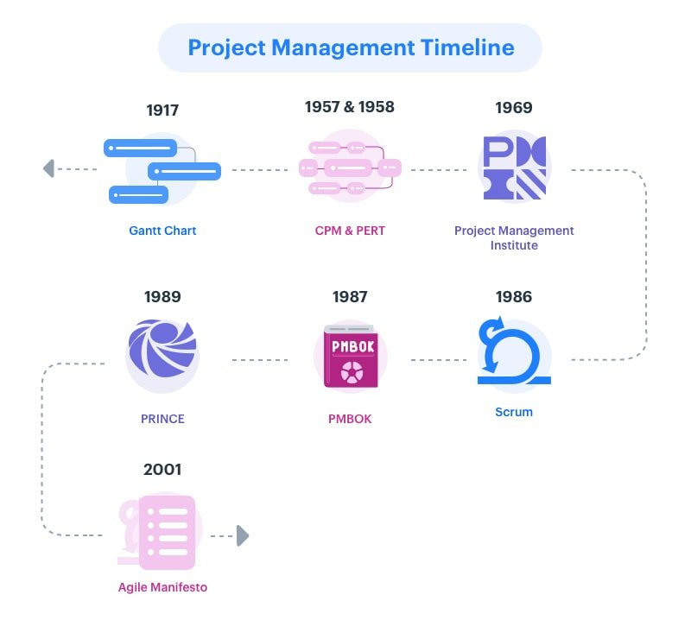

Henry Gantt introduced the eponymous [Gantt charts](https://kissflow.com/project/gantt-chart-alternatives/) in 1917. Toyota’s Taichii Ohno implemented the rudimentary form of Kanban and Lean in their manufacturing units in the 1950s. The Project Management Institute was formed in 1969. Over the years, as the nature of the market changed, newer methodologies like Agile were introduced that refined the project management process further.

## **What are the five phases of project management?**

[Project management phases](https://kissflow.com/project/five-phases-of-project-management/) are different tasks, behaviors, and skill sets that are essential to creating successful projects.  
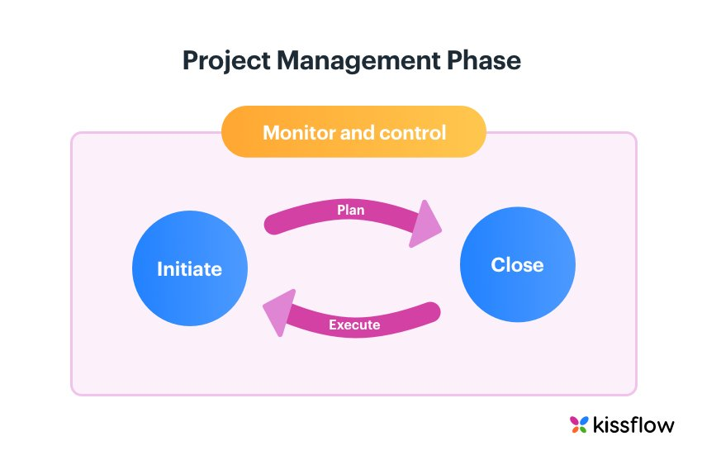

*Listed below are the five major phases of the project management process:*

### 1. Initiation

The [project initiation phase](https://kissflow.com/project/project-initiation/) marks the beginning of a project by determining high-level expectations like why a project is required, if it is feasible or not, and what is needed to complete the project.

Outputs of this phase include required stakeholder approvals to proceed to the next phase, documentation pertaining to project needs (business case), and rough estimates of time and resources required to complete the project ([project charter](https://kissflow.com/project/project-charter/)), and an initial list of stakeholders.

### 2. Planning

In the planning phase, project managers detail the [project scope](https://kissflow.com/project/project-scope-management/), time frame, and risks. Completeness and continuity are the major components of a successful [project plan](https://kissflow.com/project/steps-to-create-successful-project-plan/).

Outputs of this phase include a detailed project plan, a [project communication plan](https://kissflow.com/project/communication-in-project-management/) (if there is no project plan), budget baseline, [project scheduling](https://kissflow.com/project/basics-of-project-scheduling/), individual [project goals](https://kissflow.com/project/project-objectives/), scope document, and updated stakeholder registry.

*3. Execution*

*In the*[*project execution phase*](https://kissflow.com/project/project-execution-phase/)*, the project team members are coordinated and guided through proper project communication to get the work done as explained in the approved project management plan.*

*Additionally, this phase also covers the proper allocation and management of other project resources like materials and budgets.*[*Project deliverables*](https://kissflow.com/project/project-deliverables/)*are the output of the execution phase.*

*4. Monitoring and Control*

*During the*[*project monitoring and controlling phase*](https://kissflow.com/project/project-monitoring-and-controlling/)*, the time, cost, and performance of the project are compared at every stage and necessary adjustments are made to the project activities, resources, and plan to keep things on the right track.*

*Outputs from this phase include*[*project progress*](https://kissflow.com/project/how-to-track-project-progress/)*reports and other communications that ensure adherence to project plans and prevent larger*[*milestones*](https://kissflow.com/project/project-milestones/)*and deadline disruptions.*

*5. Closure or Completion*

*The process of finalizing the project, reviewing the project deliverables, and transitioning them to the business leaders is called the*[*project closure phase*](https://kissflow.com/project/project-closure-phase/)*in a project management life cycle.*

*This stage offers time for both celebration and reflection. Outputs from this project management phase include* *approved project results and learnings that can be applied to similar projects in the future.*

## **Popular project management approaches explained**

[Project management approaches](https://kissflow.com/project/project-management-methodologies-and-frameworks/) offer a collection of processes, methods, and tools to manage and accomplish project activities. They ensure consistency, simplify complexities, lower costs, and reduce risks. There are a number of well-established project management approaches available.

*Listed below are some of the most popular types of project management approaches:*

Phased approach in project management

Lean project management

Iterative and incremental project management

Critical chain project management

Product-based planning

Process-based management

Project production management

### **1. Phased project management approach**

A phased approach is the best choice for big and complex projects that need to be executed in stages due to external [project constraints](https://kissflow.com/project/project-management-constraints/). In this approach, each phase goes through all five process areas from initiation to closure. At the end of every phase, all the work is assessed and handed off to the next phase in a sequential way.

The phased approach is often referred to as a [waterfall or traditional model](https://kissflow.com/project/agile/traditional-vs-agile-project-management/). It is an ideal choice for small, well-defined projects. Ambiguities and risks involved rise up with the complexity and size of the project.

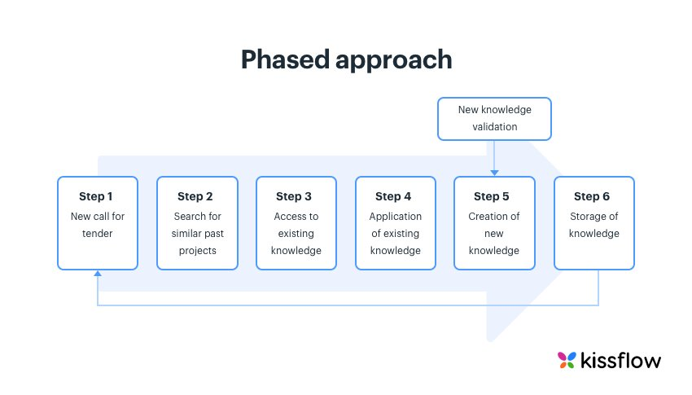

### **2. Lean project management**

[Lean project management](https://kissflow.com/project/agile/lean-project-management/) is a data-driven approach that focuses on improving the process and eliminating waste through efficient use of resources (cost, time, and people). This project management approach covers detailed planning, visual-rich documentation, continuous analysis, and frequent process improvements.

A project is considered to be lean if it follows the basic [lean principles](https://kissflow.com/project/agile/5-principles-of-lean/). Deming Cycle (PDCA), Lean Six Sigma (DMEDI), Value Stream Mapping (VSM), and [kanban methodology](https://kissflow.com/project/agile/kanban-methodology/) are some of the most popular lean project management approaches.

Most businesses lean towards value stream mapping as it offers them an accurate and detailed visualization of all steps in the project.

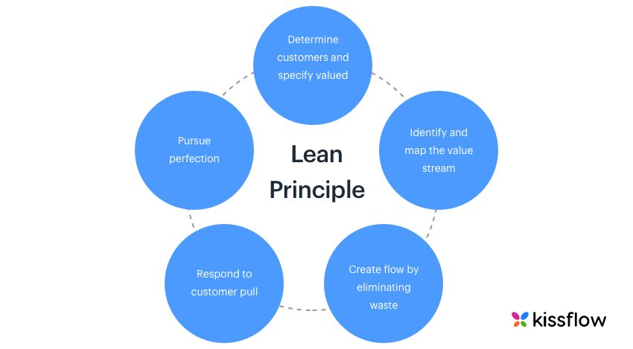

[Value Stream Mapping](https://kissflow.com/project/agile/value-stream-mapping/) (VSM) is a powerful, two-dimensional tool that documents and directs a lean transformation from a big-picture perspective. It not only helps businesses understand the total lead time but also shows individual [lead time and cycle time](https://kissflow.com/project/agile/lead-time-vs-cycle-time-in-kanban/) and provides a clear picture of wastes that inhibit project flow.

By observing and understanding the visual flow of a project, organizations can eliminate the [wastes of lean](https://kissflow.com/project/agile/8-wastes-of-lean/), reduce administrative processing time, and consistently meet project deadlines and objectives.

### **3. Iterative and incremental project management**

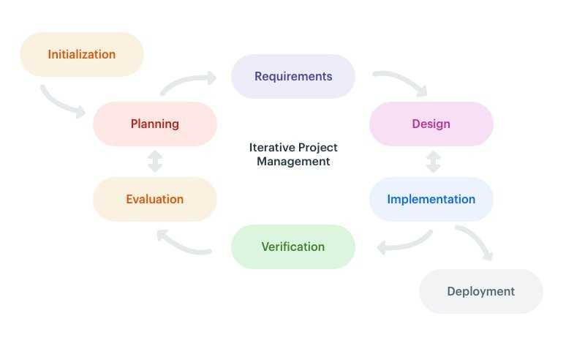

The iterative and incremental approach is a change-driven project management methodology that was developed to handle change and reduce inherent [project risks](https://kissflow.com/project/project-risk-management/). This project management methodology is a perfect choice for large-scale, multi-company projects with ambiguous requirements and a high degree of risk. It is often used for software development.

A wide range of project management approaches like [Agile project management](https://kissflow.com/project/agile/agile-project-management-methodology/), Extreme project management, and more have evolved from the incremental and iterative approach.

### **4. Critical chain project management**

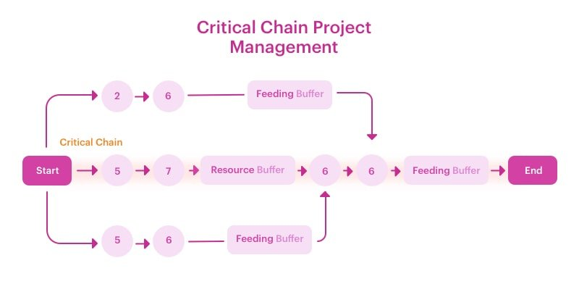

Critical chain project management (CCPM) is used to plan and manage projects while allowing room for resource constraints (personnel, equipment, and more). It is based on the [theory of constraints](https://en.wikipedia.org/wiki/Theory_of_constraints) (TOC) which states that *a chain is only as strong as its weakest link.*

In CCPM, [project delays](https://kissflow.com/project/how-to-avoid-project-delays/) are prevented by adding buffers to the inherent resource and [project task dependencies](https://kissflow.com/project/dependencies-in-project-management/).

### **5. PRINCE2 product-based planning approach**

Product-based planning is a structured project management approach that focuses on outputs and project deliverables (including intermediate products), unlike traditional approaches that focus on activities and tasks.

As there are far fewer deliverables than tasks, it is relatively easy to define and arrange them in a logical way. [PRINCE2 methodology](https://kissflow.com/project/prince2-project-methodology/) is the most common implementation of this approach.

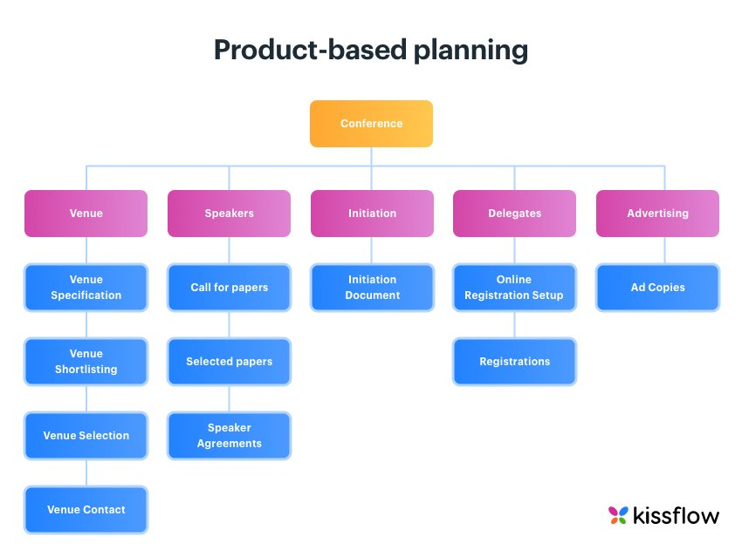

### **6. Process-based project management**

Process-based project management allows project managers to create, manage, and improve projects that align with the vision, mission, and core values of a business. All project activities and objectives are designed in such a way that they contribute towards achieving the most important organizational objectives.

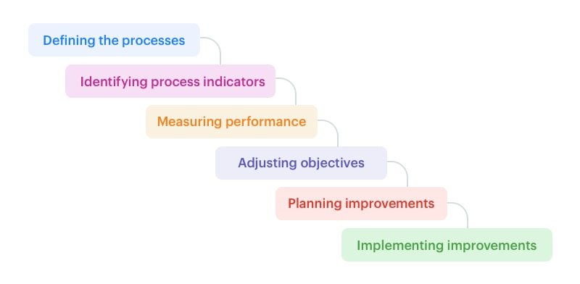

Process-based project management includes six stages:

Defining the processes

Identifying process indicators

Measuring performance

Adjusting objectives

Planning improvements

Implementing improvements

OPM3 (Organizational Project Management Maturity Model) and CMMI (Capability Maturity Model Integration) are some of the most popular process-based project management maturity models.

### **7. Project production management**

Project production management (PPM) is a strategic approach that applies theories and principles of operations science to better understand and optimize project delivery.

What makes PPM unique is the fact it uses actual data from project activities to predict limits and determine what can be genuinely achieved. It also helps in designing appropriate control mechanisms to buffer variability.

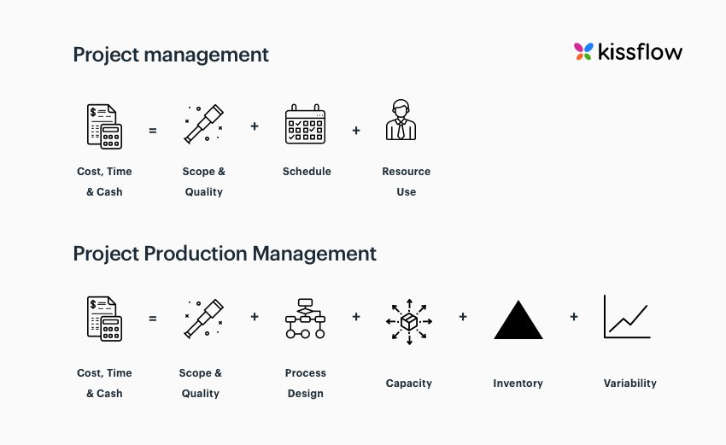

## **What are the main reasons for project failure?**

Any viable project is prone to failure due to one of the five reasons listed below:

Resource deficiency – insufficient resources to complete the project.

*Inadequate time frame –*having trouble completing the project on time.

*Unclear goals –*lack of detailed documentation can lead to inappropriate results.

*Poorly managed stakeholder expectations –*project scope changes that are not agreed upon by stakeholders causing varying views of quality, time, or budget.

*Inadequate risk management –*failing to establish the risk associated with each project can cause your project to fail.

No one starts a project with the hope that it will fail, yet most [projects fail](https://kissflow.com/project/why-projects-fail/) when project managers disregard the need to streamline their [project management techniques](https://kissflow.com/project/project-management-methodologies-and-frameworks/).

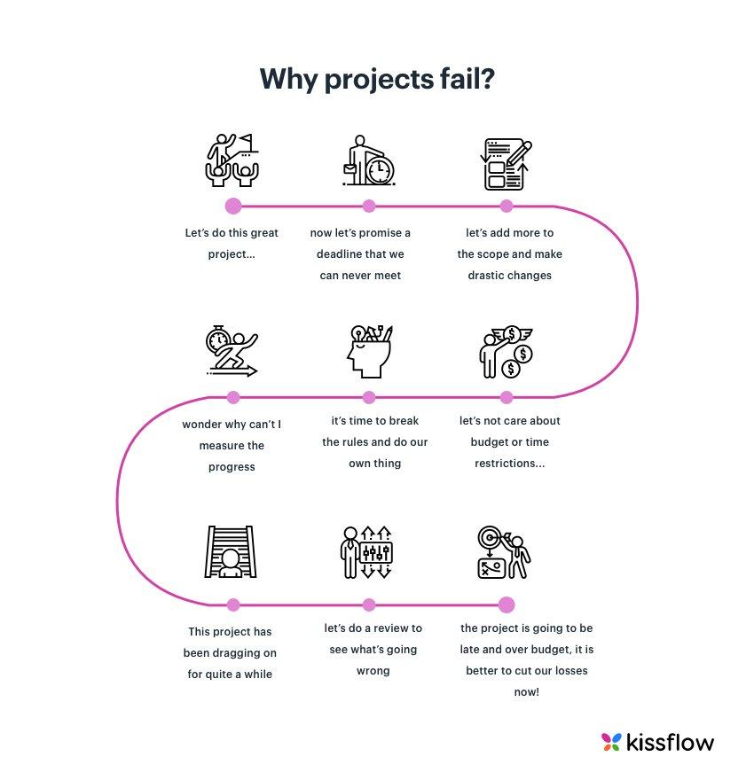

## **How to streamline project management effectively?**

Projects are filled with a slew of details. In the race to deliver the project on time, it is possible to miss a few important details along the way. Especially when project management is handled manually, it is hard to note down every small detail of a project. It results in a heap of paperwork and [spreadsheets where uncertainties thrive](https://kissflow.com/project/why-spreadsheets-are-terrible-for-project-management/) driving up the chance for failure.

While it is impossible to harness the chaos in project management overnight, there are a number of ways to streamline project management effectively.

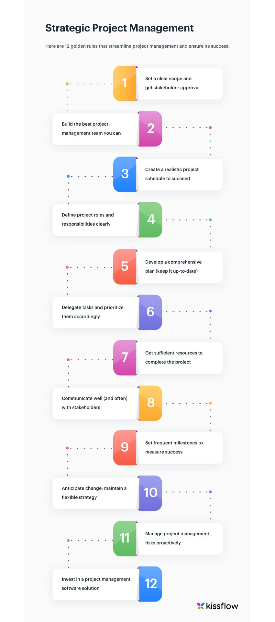

By following the twelve steps meticulously in their project lifecycle, even non-project managers can successfully streamline and complete their projects. Additionally, you can also follow the [project management checklist](https://kissflow.com/project/project-management-checklist/) and also look out for the [project management challenges](https://kissflow.com/project/project-management-challenges/) to maximize your project productivity.

## **Various types of project management structures**

One of the leading causes of project failure is the misalignment of [project teams](https://kissflow.com/project/project-team-collaboration-tips/). They lack guidance as to the organizational structure that influences the authority of the project manager.

Learn how [remote project management](https://kissflow.com/project/remote-project-management/) is done effectively and how project management teams are aligned as one.

Project management structure can be defined as the official line of control and authority within project teams as well as the organization and they tell us how reporting relationships work.

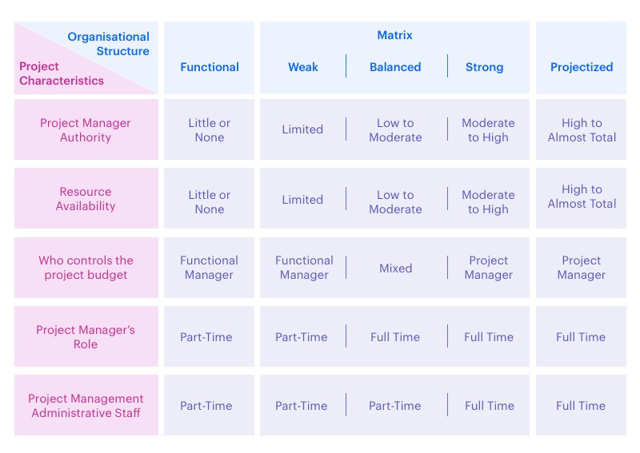

Depending on the nature of the work and the project goals, teams are structured in three ways:

### **1. Functional Organizational Structure**

It follows a hierarchical system where key decisions like budgeting, scheduling, and resource allocation lie with functional managers, who possess expertise in the same field, leaving the project manager with little to no authority.

Work is broken down into departmental units likes, sales, HR, admin. Responsibilities are predetermined and everyone knows who’s accountable. Team members get more skilled at what they’re doing.

*However, there are a few downsides to this structure:*

Work can get monotonous

[Cross-functional collaboration](https://kissflow.com/project/team/cross-functional-teams/) becomes poor

Higher levels of bureaucracy

### **2. Projectized Organizational Structure**

This organizational structure puts the project manager completely in charge. The project manager has complete authority over the budget, staffing, and schedule. The [project team](https://kissflow.com/project/project-team-management/) comprises members from across departments. At the end of the project, all team members are released to their respective functional departments.

Decisions get made faster as the project team has to navigate a lesser amount of bureaucracy. Communication becomes easier and more effective. Team members gain experience across a range of areas as they work on [different types of projects](https://kissflow.com/project/what-is-a-project/).

When team members work on [multiple projects](https://kissflow.com/project/how-to-manage-multiple-projects/), difficulties arise. There might be a clash of priorities between projects. The tight schedules and deadlines make the workplace stressful.

### **3. Matrix Organizational Structure**

The matrix organizational structures combine the best of both worlds. Reporting relationships are set up in a matrix or a grid, with dual reporting relationships i.e. every team member reports to both the functional manager and the project manager. The functional manager reviews the work which helps in improving one’s [project management skill](https://kissflow.com/project/project-management-skills/)s. The project manager prioritizes and gives direction to the work.

This organizational structure facilitates the sharing of resources. It fosters better communication and teams act as integrated units. It’s one of the toughest structures to form because of the conflicting pulls on team members and resources. Since team members report to two managers, it can create unnecessary misunderstandings and conflicts.

## **10 knowledge areas of project management you need to know**

The PMI, in its Project Management Book of Knowledge (PMBOK), divides project management into 10 digestible areas. They coincide with the chronological phases of project management and are the core technical subject areas.

* [Project integration management](https://kissflow.com/project/project-integration-management/)
* [Project scope management](https://kissflow.com/project/project-scope-management/)
* [Project time management](https://kissflow.com/project/project-time-management/)
* Project cost management
* Project quality management
* Project human resource management
* [Project communication management](https://kissflow.com/project/communication-in-project-management/)
* [Project risk management](https://kissflow.com/project/project-risk-management/)
* Project procurement management
* [Project stakeholder management](https://kissflow.com/project/project-stakeholder-management/)

## **Roles and responsibilities a project manager should have**

Similar to a project passing through a variety of project management phases, a project manager needs to assume an array of roles and responsibilities with the people involved.

These include,

1. Interpersonal
2. Information
3. Decisional and
4. Management roles.

|  |  |  |  |
| --- | --- | --- | --- |
| Interpersonal Role | Informational Role | Decisional Role | Management Role |
| 1. Work with a diverse range of professionals  2. Solve team disputes  3. Build positive relationships  4. Motivate team members | 1. Communicate with all stakeholders effectively  2. Keep people up-to-date  3. Organize team meetings frequently  4. Provide performance feedback | 1. Make a range of decisions at each stage  2. Stay clear and focused  3. Balance scope, time, and resources  4. Prevent [scope creep](https://kissflow.com/project/avoid-scope-creep-in-project/) and budget slippage | 1. Recruit and manage employees  2. Manage finances  3. Respond well to ambiguity  4. Adhere to business priorities |

If most of the responsibilities listed above sound familiar, then you’re a project manager—even if your job title doesn’t say so. By applying some of the project management best practices, you can improve the efficiency of your [team management](https://kissflow.com/project/project-team-management-software/) as a whole.

## **How do teams benefit from project management?**

Today, all organizations expect their teams to deliver more results with fewer resources. These seemingly impossible expectations can not only be fulfilled but also be exceeded if they take a project management approach towards their work.

*Some of the teams that would benefit hugely by implementing some of the*[best project management practices](https://kissflow.com/project/project-management-best-practices/):

### **1. Marketing teams:**

In marketing, there are a number of moving tasks, feedback loops, deliverables, content workflows, and due dates. With the amount of information involved, it is challenging to find the right file. Processing all of these without putting a strain on the available resources while ensuring business growth is hard without a predictable marketing project management process.

See how [marketing project management software](https://kissflow.com/project/marketing-project-management/) can help marketing operations and manage [creative projects](https://kissflow.com/project/design-project-management/) better.

### **2. Customer support:**

Good customer experience is the most important ingredient for an organization’s success. However, if the support team is preoccupied with existing chaos and juggling workload, they may not have enough time [to focus on the customer](https://kissflow.com/project/team/how-to-manage-customer-feedbacks/). Incorporating project management approaches can help your support team collaborate better, manage their workload, and communicate effectively with customers.

### **3. Product teams:**

Once the product strategy is developed and stakeholder approval is received, product managers may need to track the number of details on a day-to-day basis and work along with a variety of teams. Task management practices will help product managers translate strategy into discrete trackable tasks and communicate/collaborate with everyone effectively.

### **4. Event planners:**

To bring an event together is no small feat. It takes a lot of teamwork, frequent budget check, strict deadline adherence, a little bit of luck, and a whole lot of responsibilities to host an event successfully. Missing a small detail can make things go wrong spectacularly.

By treating events like projects, [event planners](https://kissflow.com/project/team/project-management-tips-for-event-planners/) can simplify the process of coordinating tasks and people by [visual project management](https://kissflow.com/project/visual-project-management/) to create an event that people will be talking about for years to come.

## **Manage your projects with Kissflow Project**

Now that you have put a lot of new information about project management into your brain, some of you may feel overwhelmed. Take a deep breath and look back on your own projects. Everything you’ve learned today about project management is practical. So, if you’re working on a project and you are already using some of these concepts, start using [Kissflow Project](https://kissflow.com/project/) for free.

If not, take a few minutes and reflect on how you can use these things to make your project go as smoothly as possible. Tuning your project management skills will not only help you complete your projects on time and within budget, but will also contribute to your own career and your organization’s growth.

### Difference Between Software Project and Normal Project

How Software Project Management Is Different

 The biggest difference between software and the products of other kinds of projects is it's not physical. Software consists of ideas, designs, instructions and formulas. Creating software is almost entirely a cognitive activity. The stuff we can see and measure, from code files They stand in for the real stuff, vs. the other way around. Still, software only matters when it appears as something real, even as barely real as colored squiggles on a computer screen. Maintaining that connection from thought stuff to real stuff is one of software's peculiar challenges.In comparing the management of different projects, the first trap that many people fall into is that they do not differentiate between managing the technology and managing the project process. Certainly there is a lot of difference between managing how concrete is placed and how the interface in a software development is placed on a computer screen.

But how much difference does that make to managing either project in terms of scope, quality, time, cost, risk and so on?

You can see both, even though you may not be able to see the technological processes behind either. Nevertheless, yes, there are differences but they have to do with the sophistication of the technology involved and the types of people needed for the work. For example, construction is considered to be "well established" while software development is "recent, and technologically advanced", but is certainly not unique in this regard. 

|  |  |  |  |
| --- | --- | --- | --- |
| **S.No** | **Feature** | **Software Project** | **Ordinary Project** |
| **1** | **Tangible** | Not Tangible | It is tangible |
| **2** | **End Product** | Not clearly defined | Very clearly defined |
| **3** | **Production** | No fixed production plan, difficult to monitor and track | Fixed production plan which can be tracked |
| **4** | **Productivity** | Productivity varies greatly with change in technology or worker | Productivity does not vary much |
| **5** | **Project Methodology** | Varies widely based on project | Typically standard |
| **6** | **Management methodology** | Managing a software project is more managing interpersonal communication and less administration. | It is more about maintaining schedule and good administration |
| **7** | **Transfer of Ownership** | The transfer of software is tricky as the organisation doesn’t own the hardware which runs the software | Transfer is easy as the company own the project till it hands over |
| **8** | **Multitasking** | Difficult to multitask the resources | Production resources can be used for multiple projects |
| **9** | **Personalisation** | It is very easy to change product as per customer requirement at any time. | Can be personalized to a certain extent, but difficult in the middle of the project |
| **10** | **Leadership** | Software Projects need leaders and managers, not just administrators. | A capable administrator is enough to run an ordinary project |

Many techniques in general project management also apply to software project management, but Fred Brooks identified some characteristics of software projects which make them particularly difficult :-  
  
Invisibility : When a physical artifact such as a bridge is constructed the progress can actually be seen. with software, progress is not immediately visible. Software project management can be the process of making the invisible visible.  
  
Complexity : Per dollar, pound or euro spent, software products contain more complexity than other engineered artifacts.  
  
Conformity : The 'traditional' engineer usually works with physical systems and materials like cement and steel. These physical systems have complexity, but are governed by consistent physical laws. Software developers have to conform to the requirement of human clients. It is not just that individuals can be inconsistent. Organizations, because of lapses in collective memory, in internal communication or in effective decision making, can exhibit remarkable,'organizational stupidity'.  
  
Flexibility : That software is easy to change is seen as a strength. However, where the software system interfaces with a physical or organizational system, it is accommodate the other components rather than vice versa. Thus software systems are particularly subject to change.

# Project Management | Characteristics of Project

A project is a combination of interrelated activities to achieve a specific objective within a schedule, budget, and quality. It involves the coordination of group activity, wherein the manager plans, organizes, staffs directs, and controls to achieve an objective, with constraints on time, cost, and performance of the end product. Project management is the combination of project and management.

[Planning](https://www.geeksforgeeks.org/software-engineering-project-planning/) is the strong keys to make the project more effective and well utilization of resources to achieve the goal. In this, we will focus on characteristics of the project like how objectives are important for achieving the goal, the total time duration of the project, calculated risk, and uncertainty of the project, the total estimated cost of the project, etc. are essential characteristics of the project and will discuss some other characteristics of the project like team spirit, require funds, directions, uniqueness, flexibility, and sub-contracting, etc. Let’s discuss it one by one.

**Characteristics of a Project :**    
Projects are **not homogeneous**. Each project is different in itself. The distinctive characteristics of a project are as follows.

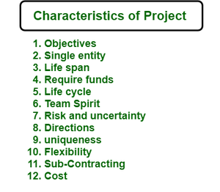

1. Objectives –  
   Every project is started with some objective or goal viz. time, budget, quality, and quantity, when objectives are fulfilled project cause existing. You can initially define the objectives of the project what actually need to achieve. Objectives are the key characteristics of the project where you will see the progress of the project and time to time analysis will show you the result of how much you have achieved.
2. Single entity –  
   A project is one whole thing. This means that in a project although different people contribute still is recognized as a single entity. The teams are often specifically assembled for a single project.
3. Life Span –  
   No project can be ceaseless and indefinite. It must have one and beyond which it cannot proceed. Every project is invariably time-bound. At the time of planning, you will see the time phase of the project where the team can work independently on the project modules. Let’s consider an example project that is divided into three modules let’s say A, B, and C. If the total time span of a project is 5 months then you can set the time span for modules independently like A can complete in 2 months and also B can complete in 2 months and C can complete in 1 month as per requirement.
4. Require funds –  
   Every project needs funds to reach the endpoint. Without adequate funds, no project can be successfully implemented. Cost estimation is one of the essential factors for any organization. So, calculating in advance the required funds for the project will be very impactful.
5. Life Cycle –  
   Each project has a life cycle with different stages like start, growth, maturity, and decay. A project has to pass through different stages to get itself completed. Let’s consider an example where the project is related to software development then you can say SDLC (Software Development lifecycle) will be the life cycle of the project where you will see many stages like planning, defining, designing, building, testing, and deployment, etc.
6. Team Spirit –  
   Team spirit is required to get the project completed because the project constitutes different members having different characteristics and from various disciplines. But to achieve common goal harmony, missionary zeal, team spirit is necessary.
7. Risk and Uncertainty –  
   The project is generally based on forecasting. So risk and uncertainty are always associated with projects. There will be a high degree of risk in those project which are not properly defined. Only the degree of control over risk and uncertainty varies with the project being conceived based on information available.
8. Directions –  
   Project is always performed according to the directions given by the customers with regard to time, quality and quantity, etc. The convenience of the supply sides of economics such as labor availability ore resources and managerial talent etc. are all secondary concerns, primary being the customer requirement.
9. Uniqueness –  
   Each project is unique in itself, and it’s having own features. No two projects are similar even if the type of organization is the same. The uniqueness of the project can measure by considering the many factors like objectives, features of the project, application of the project, etc.
10. Flexibility –  
    Change and project are synonymous. A project sees many changes throughout its life span. These changes can make projects more dynamic and flexible.
11. Sub-Contracting –  
    Sub-contracting is a subset of every project and without which no project can be completed unless it is a proprietary firm or tiny in nature. The more complexity of a project the more will be the extent of contracting. Every project needs the help of an outsider consultant, engineer, or expert in that field.
12. Cost –  
    If the quality of the project is to be changed there could be an impact on the cost of the project. The cost could increase if more resources are required to complete the project quicker.

# Problems with software projects

Last Updated on Fri, 07 Jan 2022 | [Software Project](https://www.gristprojectmanagement.us/software/)

One way of deciding what ought to be covered in 'software [project management](https://www.gristprojectmanagement.us/project-management.html)' is to consider what problems need to be addressed.

Traditionally, management has been seen as the preserve of a distinct class within the organization. As technology has made the tasks undertaken by an organization moa* sophisticated, many management tasks seem to have become dispersed throughout the organization: there are management systems rather than managers. Nevertheless, the successful project will normally have one person who is responsible for its success. Such people are likely to be concerned with the key areas that arc most likely to prevent success - they arc primarily trouble-shooters and their job is likely to be moulded by the problems that confront the project. A survey of managers published by Thayer, Pyster and Wood identified the following commonly experienced problems:

• poor estimates and plans;

• lack of quality standards and measures;

• lack of guidance about making organizational decisions;

• lack of techniques to make progress visible;

• poor role definition - who does what?

• incorrect success criteria.

The above list looks at the project from the manager's point of view. What about the staff who make up the members of the project team? Below is a list of the problems identified by a number of students on a degree course in Computing and Information Systems who had just completed a year's industrial placement:

• inadequate specification of work;

• management ignorance of IT;

• lack of knowledge of application area;

• lack of standards;

Further details of the survey can be lound in Major issues in software engineering project management' in IEEE Transactions on Software Engineering. Volume 7, pp 333-342

• lack of up-to-date documentation;

Stephen Flower's Software Failure, Management Failure. Wiley & Sons. 1996. is an interesting survey of failed computer projects

• prcccding activities not completed on time - including late delivery of equipment;

• lack of communication between users and technicians;

• lack of communication leading to duplication of work;

• lack of commitment - especially w hen a project is tied to one person w ho then moves;

• narrow scope of technical expertise;

• changing statutory requirements;

• changing software environment;

• deadline pressure;

• lack of [quality control](https://www.gristprojectmanagement.us/quality-control.html);

• remote management;

Note how many of the problems identified by the students stemmed from poor communications. Another common problem identified by this and other groups of students is the wide range of IT specialisms - an organization may be made up of lots of individuals or groups who w ill be expert in one set of software techniques and tools but ignorant of those used by their colleagues. Communication problems are therefore bound to arise.

What about the problems faced by the customers of the products of computer projects? Here are some recent stories in the press:

• the United States Internal Revenue System was to abandon its tax system modernization programme after having spent S4 billion:

• the state of California spent SI billion on its non-functional welfare database system:

• the £339 million United Kingdom air traffic control system was reported as being two years behind schedule;

• a discount stock brokerage company had 50 people working 14 hours or more a day to correct three months of records clerically—the report commented that the new system had been rushed into operation without adequate testing;

• in the United Kingdom, a [Home Office](https://www.gristprojectmanagement.us/home-office.html) immigration service computerization project was reported as having missed two deadlines and was nine months late;

• the Public Accounts Committee of the House of Commons in the United Kingdom blamed software bugs and management errors for £12 million of [project costs](https://www.gristprojectmanagement.us/project-costs.html) in relation to an implementation of a Ministry of Agriculture computer system to administer farm subsidies.

Most of the stories above relate to public sector organizations. This may be misleading—private sector organizations tend to conceal their disasters and in any case many of the public projects above were actually being carried out by private sector contractors. Any lingering faith by users in the innate ability of IT people to plan ahead properly will have been removed by consideration of the 'millennium bug", a purely self-inflicted IT problem. On balance it might be a good idea not to survey users about their problems with IT projects!

**All Parties involved in Project**

**Software projects are difficult and they all take careful planning, a talented development team and collaboration of a project’s team members, both internally within the company and externally with the software development company.**

Software projects can only move forward when the key stakeholders are all in place.

One of the keys to a successful software project is identifying and documenting the software project roles and responsibilities for your project. You’ll need to ensure that you define the key stakeholders within your business that will be involved in the delivery of the software solution.

 Get the right people. Then no matter what all else you might do wrong after that, the people will save you. That’s what management is all about.   
*-– Tom DeMarco*

Among the key stakeholders of a software project are the following eight key roles in software development and their corresponding responsibilities.

## PROJECT SPONSOR

Project Sponsors play a critical role in all projects. Project sponsors have the bandwidth to take on the Project Sponsor role, their day job and no other project role, therefore Project Sponsors are not Project Managers, Scrum Masters or Product Owners.

 Unengaged sponsor sinks the ship.   
-– Angela Waner

The Project Sponsor is **the person or group that provides direction and resources**, including financial resources for the software project. The Project Sponsor works with the project management team, aiding with wider project matters such as scope clarification, progress, monitoring, and influencing others in order to benefit the software project.

The Project Sponsor leads the project through the software supplier selection process until it is formally authorised. For issues that are beyond the control of the Product Owner, the Project Sponsor serves as an escalation path.

The Project Sponsor may also be involved in other important issues such as authorising changes in scope, phase-end reviews, and go/no-go decisions when the stakes of the project are particularly high.

Typically sponsors of projects tend to be senior management or director level executives.

## SUBJECT MATTER EXPERTS (SME)

A Subject Matter Expert (SME) or Domain Expert is a person who is an authority in a particular area or topic. A Subject Matter Expert has superior (expert) knowledge of a discipline, technology, product, business process or entire business area.

The SME role and responsibilities in software development could be summarised as follows: **they are normally the people from whom technical requirements are captured**.

 If everyone is thinking alike, someone isn’t thinking.   
-– General George Patton Jr.

Subject Matter Experts are the accountants, finance controllers, salespeople, production managers and so on who roll up their sleeves each day. They know their roles inside and out and are rarely technical.

However, their lack of technical knowledge is their strength, as they are not bogged down in technicalities and instead are purely focused on business outcomes.

It’s imperative that discussions are held with Subject Matter Experts at the same time as the software product vision statement is being created. Feedback from this group of experts can save a lot of back and forth down the line.

However, given that Subject Matter Experts tend not to be technical the right amount and type of engagement are necessary so as not to overwhelm them. One of the ways to get them involved is to have them contribute to the creation of early-stage wireframes and prototypes.

## PRODUCT OWNER

Product Owner is a software development role for **a person who represents the business or end-users and is responsible for working with the user group to determine what features will be in the product release**.

The Product Owner is also responsible for the prioritised backlog and maximising the return on investment (ROI) of the software project. Part of this role’s responsibility includes documenting user stories or requirements for the software project.

They act as the main point of contact for all decisions concerning the project and as such, need to be empowered to perform their responsibilities without the need to seek too much prior authorisation from the Project Sponsors.

Appointing the right person to this role, with the appropriate delegated authority to progress the project, is fundamental to the success of the project, especially if an agile methodology approach is undertaken.

In particular, the Product Owner is responsible for:

* ensuring that the software product vision statement is adhered to
* making the final decision on all scope related decisions
* maintaining and updating the product backlog on a continuous basis by
  + refining new requirements
  + removing requirements that fall out of scope
  + adding new requirements identified as being required to achieve the software product vision statement
  + reviewing and setting the priorities assigned to the product backlog and heading up all project planning meetings
* resolving any disputes either with the software development team or internally

Failure to have a Product Owner in place usually means that the software project will execute in fits and starts whilst the [**software developers**](https://www.atlascode.com/) are on hold waiting for crucial feedback.

A slowdown in the momentum of a software project can have long-term consequences, not least of missed milestones and deadlines. Don’t ever underestimate the importance of the Product Owner role in the success of your software development project.

## PROJECT MANAGER (PM)

The Project Manager (PM) is **responsible for knowing the “who, what, where, when and why” of the software project**. This means knowing the stakeholders of the project and being able to effectively communicate with each of them.

The Project Manager is also responsible for creating and managing the project budget and schedule as well as processes including scope management, issues management and risk management.

Some of the Project Manager duties can include:

* Developing a software project plan
* Manage deliverables according to the software project plan
* Recruiting software project staff
* Leading and managing the software project team
* Determining the methodology used on the project
* Establishing a project schedule and determine each phase
* Assigning tasks to project team members
* Providing regular updates to senior management

It doesn’t matter if you are using an agile methodology or the waterfall method, once deliverables are defined, it is critical that the Project Manager starts to actively exercise change management. Change should not be perceived as negative or something to be avoided.

Change is inevitable and is acceptable in a software project as long as it is managed. The impact of any change needs to be assessed, measured and communicated. The major factors are typically timeline and budget. If the impact is deemed acceptable by the Project Sponsor, then the change can be incorporated.

The Project Manager also oversees [**software testing**](https://www.atlascode.com/services/software-testing/), delivery and formal acceptance by the customer. Then the Project Manager performs a project review with the software development team to document any lessons learned from the [**software development processes**](https://www.atlascode.com/process/).

## TECHNICAL LEAD

This person **translates the business requirements into a technical solution**. Because of this responsibility, it is beneficial to have the Technical Lead involved in the planning phase to hear the business requirements from the customer’s point of view and ask questions.

The Technical Lead is the development team leader and works with the developers to provide technical details and estimates for the proposed solution. This information is used by the Project Manager to create the Statement of Work and the Work Breakdown Structure documents for the software project.

It is critical that the Technical Lead can effectively communicate the status of the software project to the Project Manager so that issues or variances can be effectively addressed as soon as possible.

The Technical Lead is also responsible for establishing and enforcing standards and practices with the software development team.

## SOFTWARE DEVELOPERS

The Software Developers (front-end and back-end) are **responsible for using the technical requirements from the Technical Lead to create cost and timeline estimates**.

The Software Developers are also responsible for building the deliverables and communicating the status of the software project to the Technical Lead or Project Manager.

It is critical that the other team members effectively communicate the technical requirements to the Software Developers to reduce project risk and provide the software project with the greatest chance of success.

## SOFTWARE TESTERS

The Software Testers ensure that the software solution meets the business requirements and that it is free of bugs, errors and defects.

In the test planning and preparation phases of the [**software testing**](https://www.atlascode.com/services/software-testing/), Software Testers should review and contribute to test plans, as well as be analysing, reviewing and assessing technical requirements and design specifications.

Software Testers are involved in identifying test conditions and creating test designs, test cases, test procedure specifications and test data, and may automate or help to automate the tests.

Some of the Software Testers duties can include:

* They often set up the test environments or assist system administration and network management staff in doing so
* As test execution begins, the number of testers often increases, starting with the work required to implement tests in the test environment
* Testers execute and log the tests, evaluate the results and document problems found
* They monitor the testing and the test environment, often using tools for this task, and often gather performance metrics
* Throughout the software testing life cycle, they review each other’s work, including test specifications, defect reports and test results

## USER ACCEPTANCE TESTERS

You should expect your software solution provider to carry out a wide array of software testing to **ensure that your new software solution meets various quality assurance (QA) criteria**.

On from that, representatives of your company will need to perform the final checks to ensure that the software works for the business across a number of real-world scenarios.

User Acceptance Testing (UAT) is the final step prior to a new software solution being released to production (live). It’s absolutely essential that you have the resources to tackle user acceptance testing in a timely and organised fashion, as it is often UAT that creates the bottleneck between the software solution being completed and released to the business.

It’s often the case that the aforementioned Subject Matter Experts defined how the new software solution should work and, given their close proximity to the actual work, they can make excellent User Acceptance Testers.

 When end users get involved in the final stages of testing, light bulbs go on, and they often have an “aha” moment. Unfortunately, that is often too late.   
-– Frank R. Parth

It’s an excellent idea to ensure that those employees participating in UAT are brought in from the start, and understand, or perhaps better still contribute to, the design of the new software solution.

This emotional buy-in and understanding of the software solution’s objectives reduces the friction that might otherwise exist in attempting to move end-users from the existing software systems they know, love and use every day.

#### **SOFTWARE DEVELOPMENT ROLES – CONCLUSION**

Whilst it’s important that your software solution provider has the necessary resources in place to operate your project, it is equally as important that you as the customer understand the roles and responsibilities required within your team to bring your project to successful completion.

**The key to project success is clear and effective communication**. A critical portion of this communication is identifying the stakeholders and their roles.

Whatever labels you apply to the software project roles above, clear communication of expectations and status to the stakeholders throughout the life of the software project will increase the chances of your project’s success.

# What Is A Project Management Framework? (Must Read)

A Project Management Framework (PM) is a plan to ensure project completion. All projects have a specific goal with a completion date.

This structured plan enables all involved to keep on track with the project. It also explains everyone’s responsibility to ensure the success of the project. A designated project manager manages the project from start to finish.

Project Management Framework includes three major parts: lifecycle, control cycle, and tools. These are necessary for implementing and completing a project.

### **Project Management Framework**

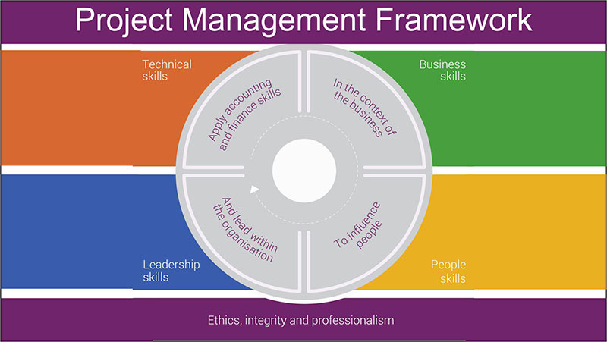

What is the framework? It enables the use of more effective strategies. It establishes a common language to be used so that all can understand one another.

Framework also allows for more flexibility. As a project progresses, the possibility of an earlier completion may arise. Working with a variety of professionals allows the key personnel to better manage the project.

There are a variety of frameworks. Each has its defined methodology. This article created by our team at [TMS](https://tms-outsource.com/), will discuss a few of those available. The analysis will help project managers to choose the framework that is best for their project.

## **Seven Effective Project Management Frameworks**

The project management framework chosen depends on the size of the organization, type of work, budget, industry, and timeframe. Listed below are seven different types of frameworks.

### **Prince2**

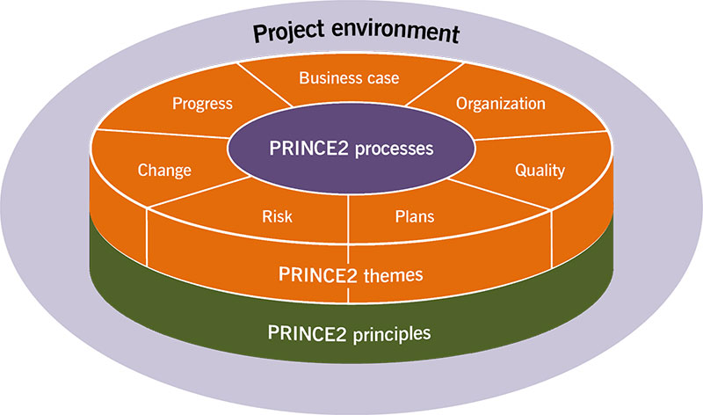

Prince2 is a project management framework program and methodology. It divides the project into controllable steps. The training module is available in a variety of languages.

This framework was originally developed as a UK government standard for IT project management. Its phases consist of business case analysis, organization, quality, plan, risks, change, and progress.

### **CCPM**

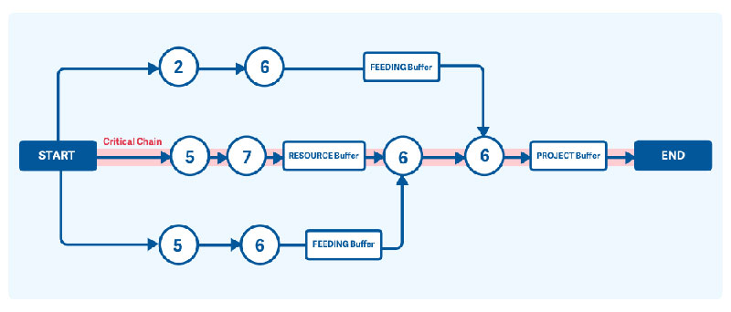

The methodology focuses on people, resources, and physical spacing. The Critical Chain Project Management program is noted for helping to complete projects faster. This is due to the rigid scheduling of tasks.

As a result, CCPM cuts back on project costs which is beneficial for those working within a strict budget.

### **Lean**

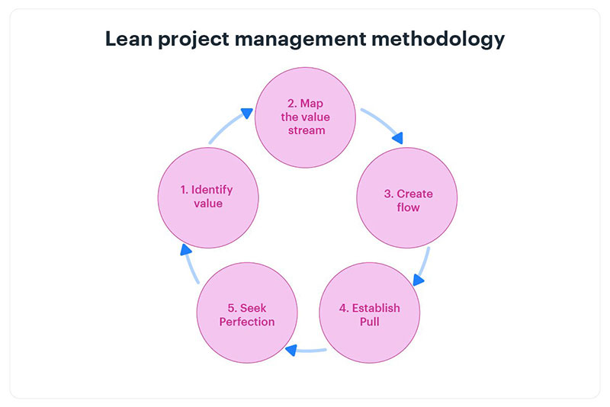

The lean project management framework focuses on delivering quality service by using resources efficiently. Its methodology is derived from the Toyota Production System (TPS). TPS focuses on creating less waste and providing quality products to the consumer.

### **Agile**

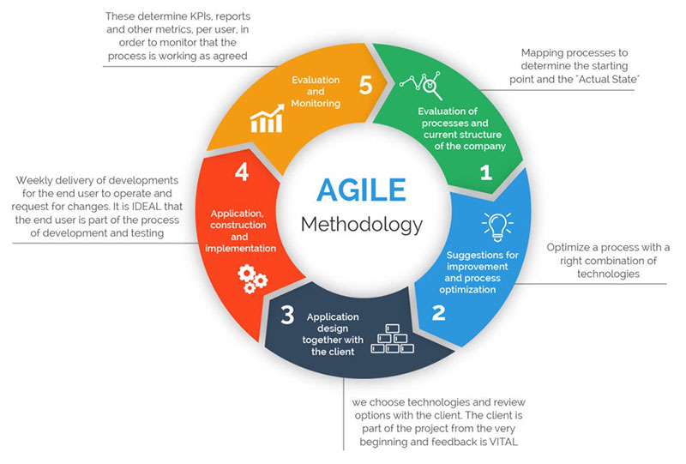

The agile project management framework aims to provide maximum value to clients within the desired timeframe and budget. It allows for flexibility. There is no need for extensive planning before the project starts.

The project manager collaborates with the Stakeholders throughout the project. This allows them to make adjustments along the way.

### **Waterfall**

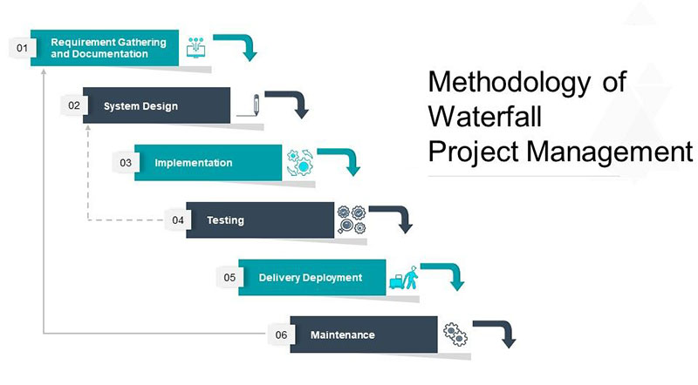

The waterfall is a more traditional framework with tasks carried out in phases. One phase must be completed before starting the next one. Waterfall outlines a defined planning framework with all phases taking place in exact order.

### **Scrum**

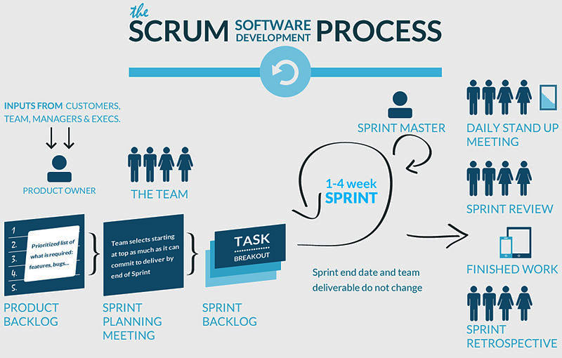

Scrum project management framework is good for small projects. There is no complex planning needed before the project starts. The team meets daily to discuss tasks and any roadblocks to overcome. Tasks are accomplished in short succession.

### **XPM**

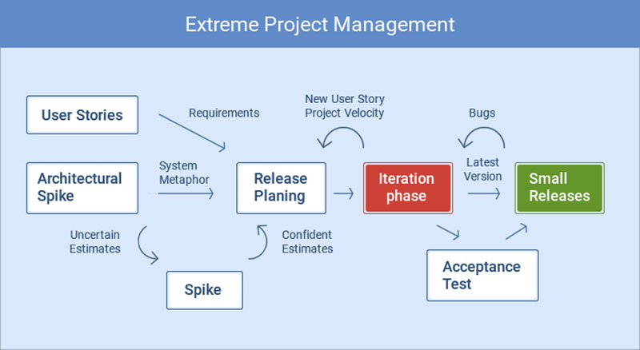

Managing complex projects in complex environments is known as Extreme Project Management (XPM). XPM is perfect for those who expect unstable circumstances during the project.

Before starting the project, the project manager invites Stakeholders to a meeting. The object of this is to discuss the [project plans](https://venngage.com/blog/project-plan-template/), as well as any unexpected situations that could arise.

### **Major Components of a Project Management Framework**

The three major components of PM are lifecycle, control cycle, and tools.

The lifecycle consists of five processes. These are: Initiation process, planning process, execution process, monitoring process, and project closing process.

* The initiation process is the starting point. Discussion of the project goal begins. The viability of the business case is determined when the Project Manager meets with the Stakeholders.
* In the planning process, the project goals are defined. There are two types of goals: Smart goals and Clear goals. Smart goals are specific, measurable, attainable, realistic, and timely. Clear goals are collaborative, limited, emotional, obvious, and refinable. This stage also involves the discussion of roles and responsibilities.
* During the execution process responsibilities are officially Updates and project status reports are developed.
* The monitoring process requires the Project Manager to assess the project. An update is issued to the Stakeholders regarding the project status. Adjustments to schedules and resources can occur at this point.
* Project closing indicates the project is reaching the completion stage. Contractors complete their workload.The project manager informs the Stakeholders of the project accomplishments. The remaining team members are assisted to complete any loose ends.

The control cycle entails monitoring results and making adjustments as needed. The use of software aids in this aspect of Project Management. Stakeholders are informed about the progress of the project. Through good communication, the Project Manager may discover that adjustments should be made to keep the project on track.

The tools component of PM includes software that allows you to track the progress of the project.

### **What’s the difference between Framework and Methodology?**

The framework is a basic structure for understanding project management. It deals with the processes to accomplish a project, but also allows for other practices and tools to be used. It also includes phases that may not be mentioned in the methodology. For example, complex onboarding processes and assessments may be undertaken.

This allows the structure to develop and become more effective. Prince2 and Waterfall are examples of frameworks.

Methodology sets defined rules that help direct the project. They govern how people will interact and communicate with one another.

The methodology also gives organizations a standard to work by. With each completed project organizations discover which rules work and which rules do not. This allows them to develop more efficient standards to govern future projects. As a result, methodology contributes to an increase in successful projects.

Two examples of the methodology are Lean and Waterfall. The Lean methodology focuses on reducing waste of both resources and time. The Waterfall methodology involves planning the whole project and executing it in phases.

## **Ending thoughts on the project management framework that we talked about**

The framework is crucial to the success of Project Management. It gives structure to a *project*, allowing others to see how they can achieve the project goal.

Project managers have a variety of frameworks to choose from. The right framework makes it possible to achieve the goals of the stakeholders.

It can also help an organization see how it can improve its processes. This contributes to completing the project on time, and to more efficient use of resources.

**UNIT 2**

## **What is project integration management?**

Project integration management involves [coordinating all elements of a project](https://asana.com/resources/project-coordination-tips), including tasks, resources, stakeholders, and deliverables. The purpose of project integration management is to ensure that processes run efficiently and meet predefined goals.

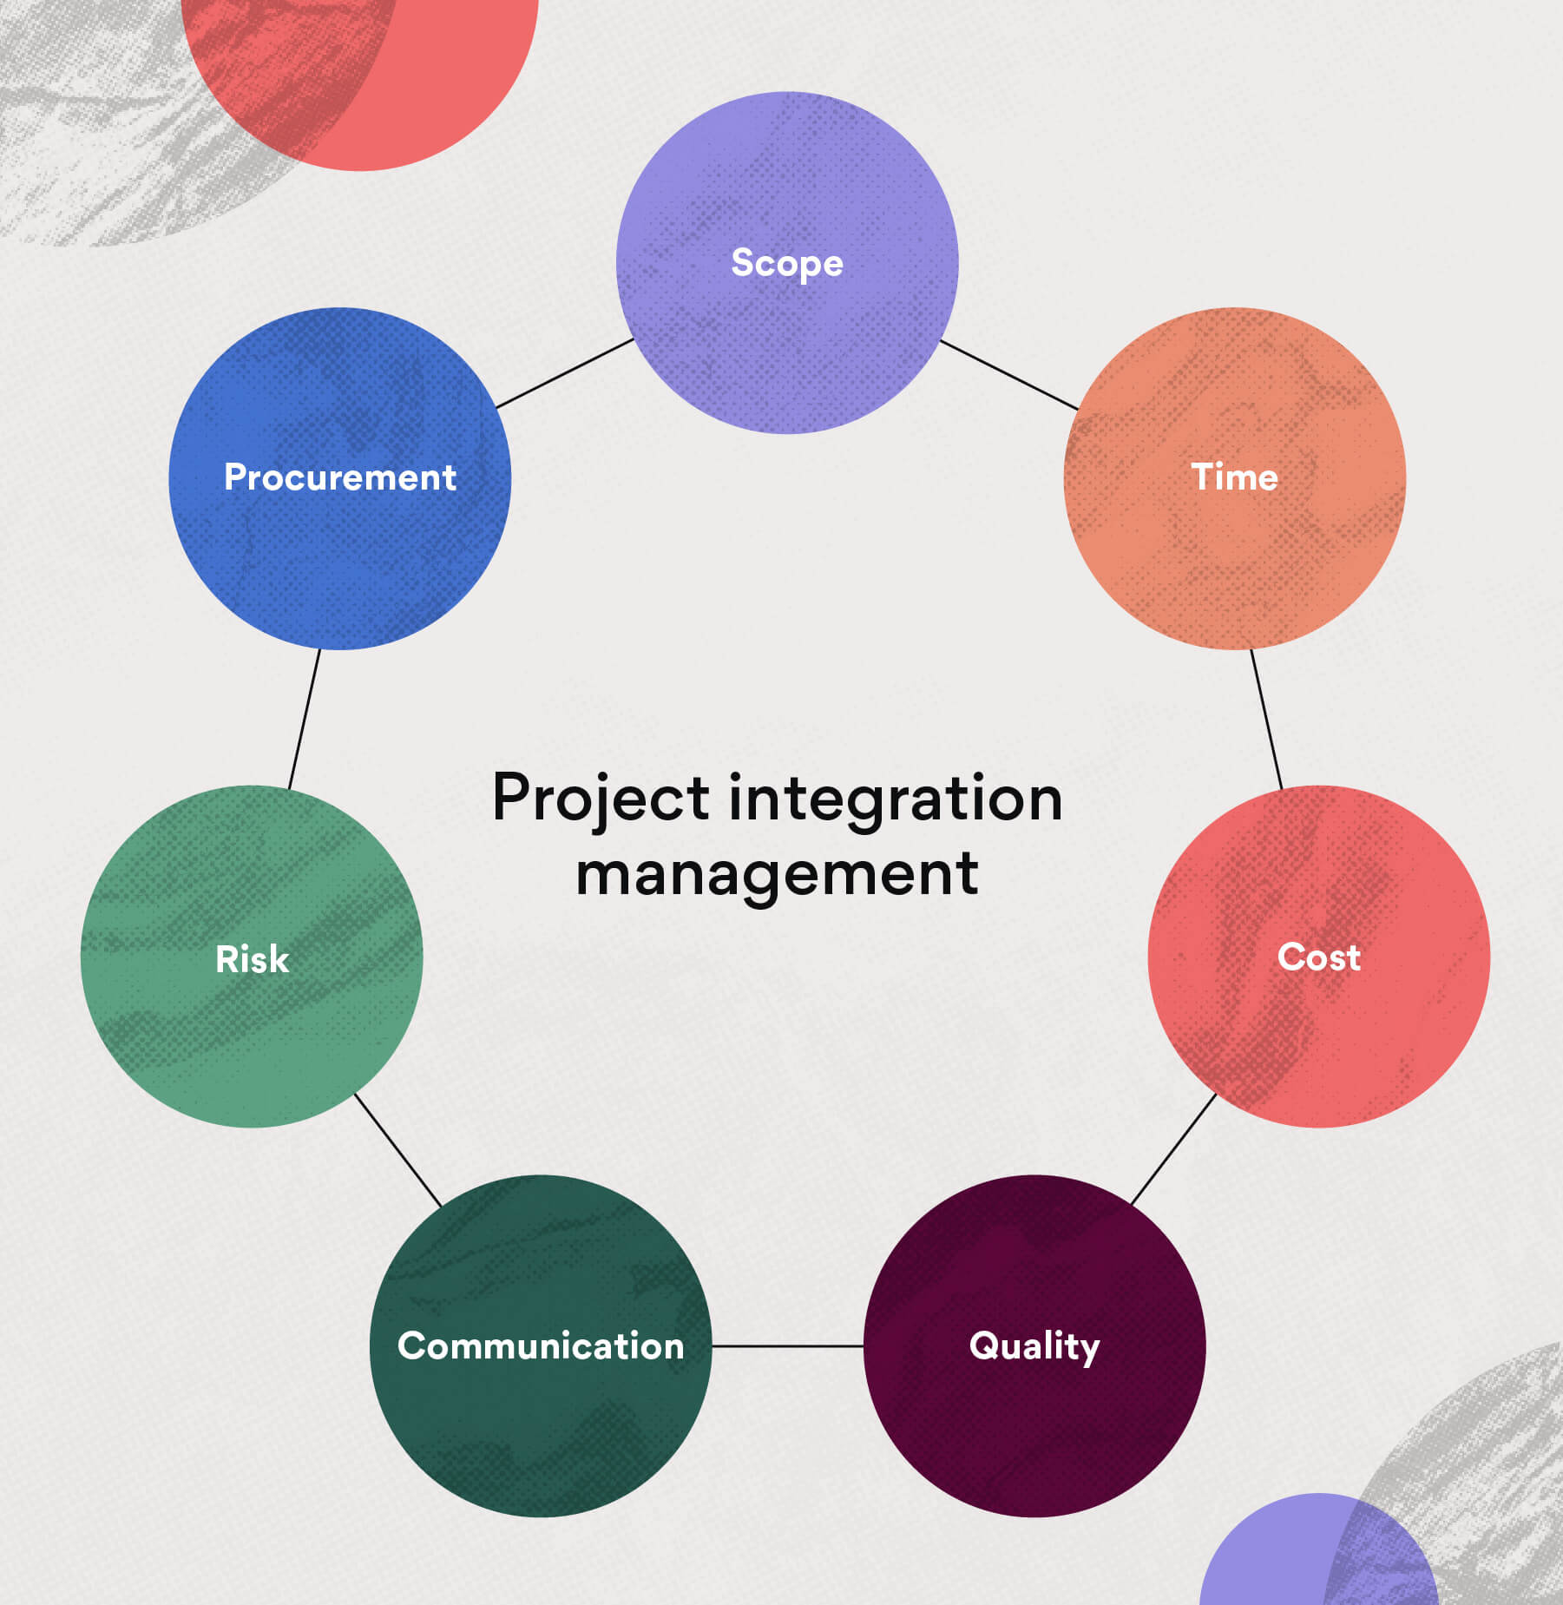

You need project integration management when there are interactions between different processes and teams. When projects have competing objectives or scheduling conflicts, project integration management helps you make cost or schedule trade-offs that enable your team to complete the project and meet stakeholder expectations.

Here’s a project integration management example: Let’s say the marketing team requires data from the sales team in order to produce a report for stakeholders. Project integration management is used to ensure that the data from the sales team is properly handed off to the marketing team and that the deliverable meets requirements.

Project integration management also involves overseeing the five [project management phases](https://asana.com/resources/project-management-phases) that occur during the project lifecycle.

These five phases include:

1. Project initiation: The aim of this phase is to establish the vision and goals for the project and secure stakeholder approval through project objectives. This phase consists of creating the [project charter](https://asana.com/resources/project-charter) to provide an overview of the project, a clear road map, and the stakeholder register to specify the stakeholders involved.
2. Project planning: The planning process is where you set up the project infrastructure to help you achieve the project goals within time, budget, and resource constraints. You’ll create more detailed project documents to help your team understand the project vision and what’s required to see it through.
3. Project execution: This is when you’ll put your [project plan](https://asana.com/resources/project-management-plan) into action and get the project underway. Most of the budget will be spent during this phase to produce the deliverables. It also includes activities such as stakeholder communications and engagement, quality assurance, and team development.
4. Project performance: This phase involves supervising the progress of the project and comparing it against the original plan. It means taking corrective action when there are blockers or delays.
5. [Project closure](https://asana.com/resources/project-closure): This is where you formally close out the project by getting approval from the client or stakeholder. Records and lessons learned from the project should be archived for future reference.

As one of the key knowledge areas in the PMI’s [PMBOK® Guide](https://www.pmi.org/pmbok-guide-standards) (Project Management Book of Knowledge), mastering this practice allows project managers to improve their processes.

## **The 7 steps of project integration management**

Project integration management offers a holistic approach to project planning and execution. The practice consists of seven processes to effectively coordinate project activities. Let’s break them down.

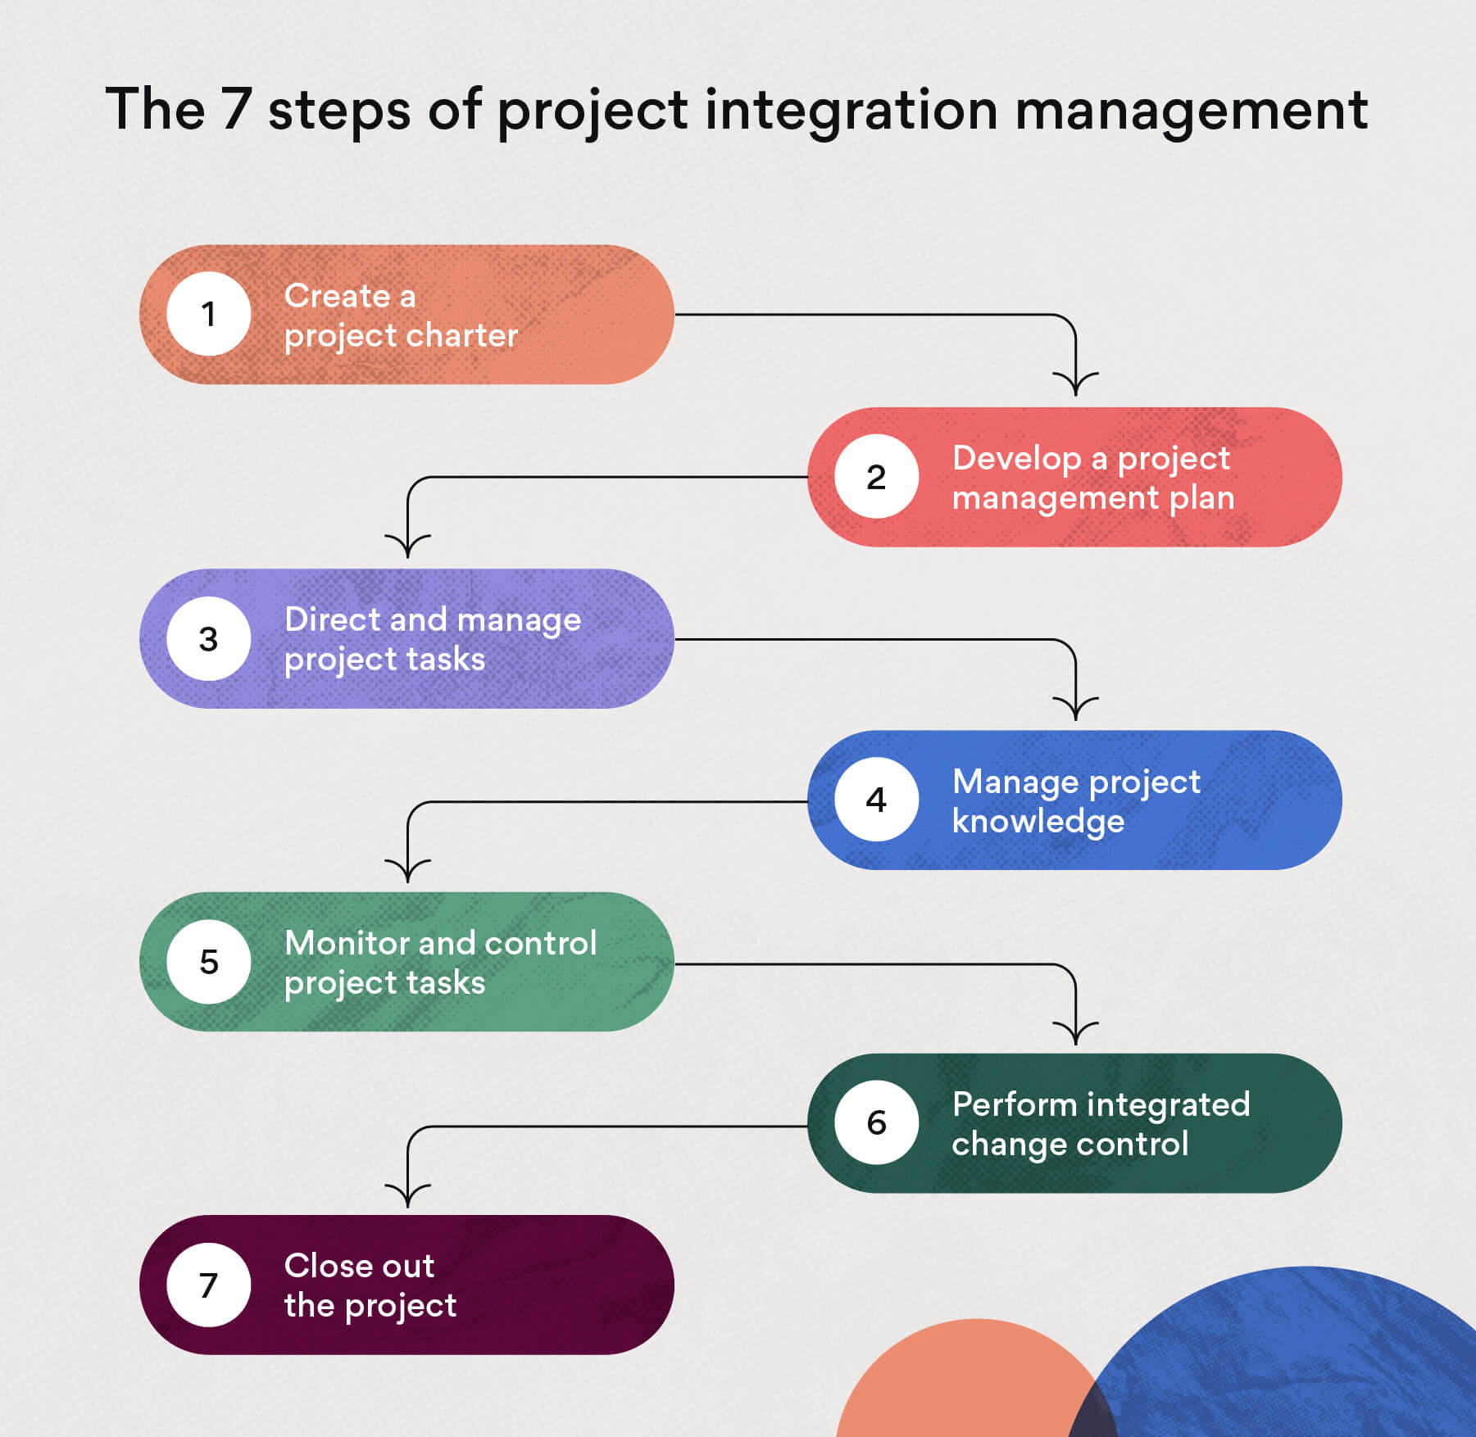

### **1. Create project charter**

Projects typically start out with the creation of a project charter, a short document that provides an overview of the project and identifies the project manager and [key stakeholders](https://asana.com/resources/project-stakeholder).

A project charter includes the following:

* Scope
* Objectives and deliverables
* Project team members
* [Project risks](https://asana.com/resources/project-risks)
* Benefits or returns on investment
* Budget
* [Business case](https://asana.com/resources/business-case)

A project charter essentially acts as a foundation on which you can further plan your project. It also helps you gain buy-in from stakeholders, which enables you to move forward quickly and autonomously within the [project scope](https://asana.com/resources/project-scope).

[Read: 7 common causes of scope creep, and how to avoid them](https://asana.com/resources/what-is-scope-creep)

### **2. Develop project management plan**

The next step involves developing a more detailed [project plan](https://asana.com/resources/project-management-plan), which specifies the project scope statement, deliverables, [timeline](https://asana.com/resources/create-project-management-timeline-template), [milestones](https://asana.com/resources/project-milestones), and metrics to evaluate success.

The project plan is used to direct the execution of the project to meet overall requirements and objectives.

Here are the steps to creating a project management methodology:

1. Meet with stakeholders to set project requirements, deliverables, and objectives.
2. Define the project scope.
3. Create a [work breakdown structure (WBS)](https://asana.com/resources/work-breakdown-structure) to delegate tasks and assign resources.
4. Create a [project schedule](https://asana.com/resources/project-timeline-schedules).
5. Conduct a risk assessment and develop [contingency plans](https://asana.com/resources/contingency-plan).
6. Come up with a performance measurement baseline to assess project performance.
7. Develop additional plans for any of the following: scope management, [cost management](https://asana.com/resources/cost-management-steps), [resource management](https://asana.com/resources/resource-management-plan), [change management](https://asana.com/resources/change-management-process), [stakeholder management](https://asana.com/resources/project-stakeholder), or [risk management](http://asana.com/resources/project-risk-management-process).

To help you with this process, you can use a [project planning template](https://asana.com/resources/project-plan-templates) as a starting point to build your plan.

### **3. Direct and manage project work**

The next phase is project execution, in which the project manager takes charge of the day-to-day work that must be done, such as:

* Directing the project team
* Holding stakeholder meetings
* Tracking project progress

This phase ensures that tasks are being carried out effectively according to the project plan and scope statement.

### **4. Manage project knowledge**

Project knowledge management refers to the process of using existing information or obtaining additional knowledge to reach project goals. This step ensures team members have all the information they need to produce the required deliverables.

Any knowledge or expertise gained during this step contributes to the company’s overall body of knowledge, which is useful for future strategic endeavors.

### **5. Monitor and control project work**

Since processes in project integration management are interconnected, they should be followed closely to ensure that everything adheres to the project management plan.

The purpose of this step is to keep the project on track. If there are any deviations from the project plan, they need to be identified and corrected.

There are three approaches to this:

1. Preventive action: an action performed to reduce the negative impact of project risks
2. Corrective action: an action performed to bring the future project performance back in line with the project plan
3. Defect repair: an action to repair or replace a documented project defect

A common technique to measure performance is to do an earned-value analysis to assess the current status of the project’s budget and schedule. If project changes need to be made and are approved, project documents such as the work performance report may need to be updated.

Monitoring the project ensures that it is on track to meet objectives.

[Read: How to write an effective project objective, with examples](https://asana.com/resources/how-project-objectives)

### **6. Perform integrated change control**

Changes to projects can sometimes be stressful if not handled properly, but with a [change control process](https://asana.com/resources/change-control-process) in place they don’t have to be.

That’s why change requests must be assessed to ensure they don’t exceed the scope or approach [scope creep](https://asana.com/resources/what-is-scope-creep), which refers to the increase in requirements during the project lifecycle. Some companies even have a dedicated change control board to review change requests related to budget, timelines, and resources, for example.

An example of project change is if the client asks for additional assets, in which case you’ll need to evaluate the level of impact on the project.

Use a change control log to document all change requests, including which ones were approved, the associated costs and resources, and how they impact the project timeline. Smooth integration of change requests to current project activities is crucial for the success of the overall project.

[Read: What is change management? 6 steps to build a successful change management process](https://asana.com/resources/change-management-process)

### **7. Close out the project**

After all project work is complete and deliverables are shipped and approved by the client, it’s time to close the project.

Project closure involves processes such as:

* Holding a final stakeholder meeting
* Conducting a formal review of the project
* Closing the contract
* Organizing and archiving project materials for future use

Project closure serves as a reference for future endeavors and provides insight on how to improve the project integration management system.

## **How to implement project integration management**

Performing project integration management requires a combination of technical and leadership skills. Here are some tips to help you get started with project integration management.

### **Have a project manager oversee integrated project management**

Projects have many moving parts to keep track of and a project manager plays an important role in resolving conflicts. A [project manager](https://asana.com/resources/become-a-project-manager) oversees:

* Project schedule
* Costs
* [Project deliverables](https://asana.com/resources/what-are-project-deliverables)
* Risks
* Project goals
* Resources

Project managers need a thorough understanding of how each factor affects one another and the overall impact on the project. Integrated project management specifically involves a process, phase, and output that the project manager keeps track of.

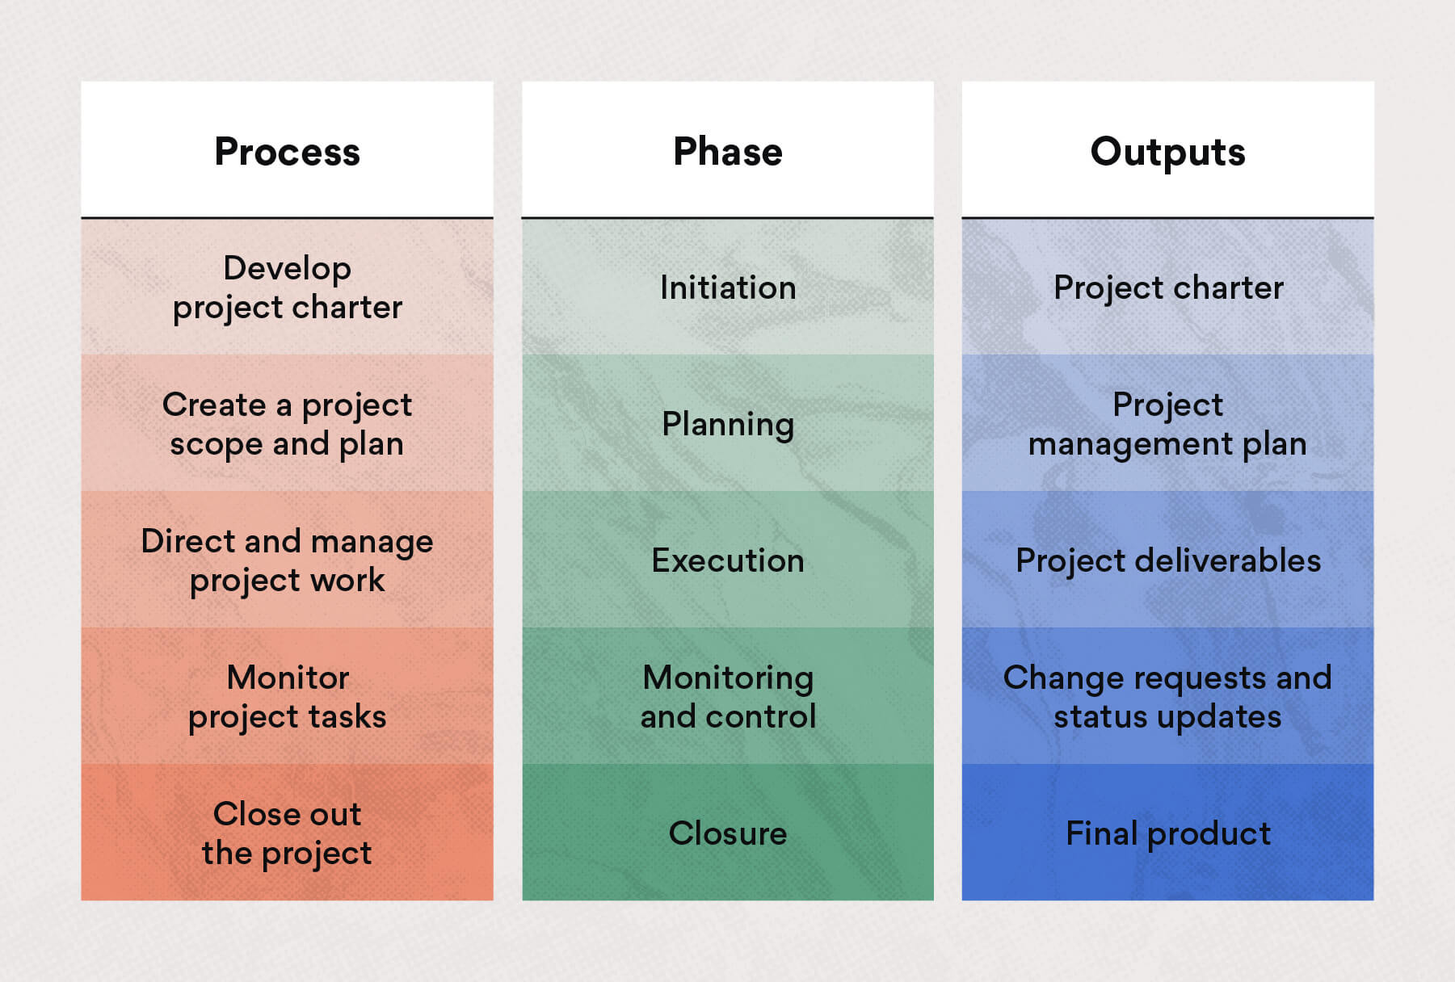

For instance, if a project has a change in scope, you may run the risk of resource shortages, budget overruns, and delays. Project integration management allows you to reorganize teams and redistribute resources as required to minimize impact to the project and business.

Project integration management can be especially helpful when you have to manage cross-functional teams and organize their project interdependencies.

[Read: 25 essential project management skills you need to succeed](https://asana.com/resources/project-management-skills)

### **Track time diligently**

If you don’t already, implementing time-tracking software could be beneficial, not only for billing purposes but also for future project scheduling. While [team calendars](https://asana.com/uses/team-calendar) provide a high-level overview of how time will be allotted, tracking the number of hours spent on tasks gives you more precise metrics.

Having this data on hand will be useful for scheduling future projects since it’ll help you make more accurate estimates when planning out specific tasks.

### **Establish well-rounded project teams**

A good project team can make all the difference in project performance. It’s your job to put together a balanced project team and assign tasks to match team members’ skills and expertise. Make sure everyone has the resources they need and coordinate communication between the teams involved.

### **Use project templates to save time**

Creating project plans and materials can be time-consuming, especially given how many are required for a single project. Rather than making them from scratch, take advantage of project templates, either from previous projects or premade ones.

For example, [project plan templates](https://asana.com/templates/for/other/cross-functional-project-plan) or [meeting agenda templates](https://asana.com/templates/for/other/meeting-agenda) can be tailored for various purposes. Templates provide you with a base that you can alter and customize to suit your needs.

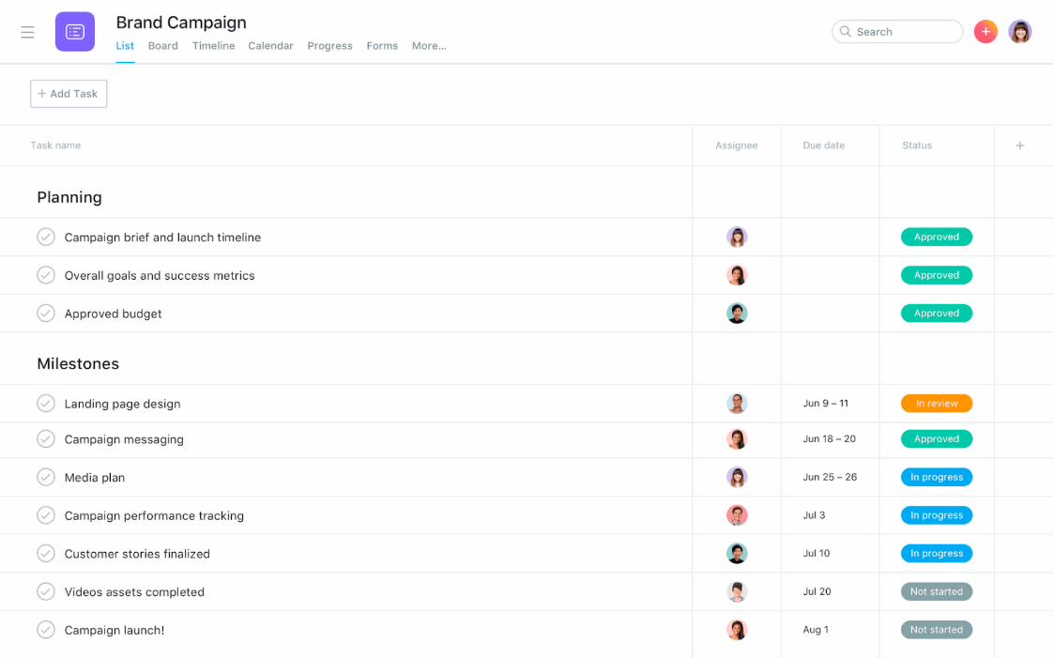

### **Collaborate with a team communication tool**

Each department has their own communication styles and tools, and projects often require collaboration between different departments.

To prevent miscommunication or a lack of communication between teams, use a [communication plan](https://asana.com/resources/communication-plan) to establish which channels teams should use to share knowledge, resources, and [project status updates](https://asana.com/resources/how-project-status-reports). That way, teams can directly communicate with one another and you don’t have to act as the intermediary.

For example, [team communication tools](https://asana.com/uses/team-communication) allow you to create a centralized hub for projects, enabling real-time communication and feedback. T[eam communication tools](https://asana.com/resources/team-communication-tools) can also complement the tools you already use since they can integrate with popular remote work tools like Google Drive and Slack.

## **The importance of project integration management**

Projects are often dynamic and complex, involving multiple teams and organizational processes. To ensure all elements are working cohesively toward the end goal, project integration management is necessary. Here are some benefits of this practice.

### **Provides coordination and organization throughout the entire project**

Project integration management is like an instruction manual you can use to help steer the project in the right direction and make sure all the processes are in sync. As the project moves from phase to phase, it ensures the outputs and documents are in order for the next phase to go smoothly.

[Read: 5 project management phases to improve your team’s workflow](https://asana.com/resources/project-management-phases)

### **Ensures everyone understands their responsibilities**

With project integration management, all stakeholders and team members will have a clear understanding of their roles and responsibilities. By monitoring the project diligently, you’ll be able to address questions from teams or stakeholders if there are any points of confusion or issues.

### **Keeps project on track**

Project integration management keeps projects on track to meet the deadline and budget. It also keeps the project aligned with the project management plan in order to get the promised results or returns. Project integration management helps you resolve conflicts or changes while minimizing the impact on the overall project.

### **Maintains smooth communication with stakeholders**

Integrated project management ensures stakeholders are kept up to date on project progress. It allows you to create a system for communicating with stakeholders regarding project changes, whether they’re approved or not. It also emphasizes the importance of holding a final meeting after the project is completed to get closure.

[Read: How to write an effective project status report](https://asana.com/resources/how-project-status-reports)

### **Makes decisions more clear**

Each step in project integration management has defined purposes and outputs. By walking through all the steps, you’ll be able to gain deeper insight into the best course of action for each project phase. Creating thorough project documentation will also allow you to clearly communicate the reasoning behind the plans.

Overall, project integration management benefits everyone involved in the project—the project team, project manager, and stakeholders.

## **Deliver results with project integration management**

Project integration management brings all your project processes and tasks together. With Asana’s project management software, you have a single source of truth for planning and organizing projects from start to finish.

# What Is Project Scope Management? An Overview

**Project Scope Management** is a defined process for completing a temporary project. It is an essential element for the function of any team, ensuring maximum efficiency, eliminating unnecessary or redundant work, and keeping a team on the same page every step of the way. Project scope will also help manage the client’s expectations and keep the project on time and on budget.

## **What is project management?**

Project Scope Management refers to a set of processes that must be completed in order to deliver a “project,” which could be a product, service or result with specific features or functions. Scope Management focuses on “how we get there” or perhaps more accurately “what steps do we take to get there?” These steps are defined and mapped so that project managers and supervisors can determine the amount of work needed and where to focus efforts of the team in order to complete the project.

Project Scope Management should not be confused with **Product Scope Management**, which focuses more on the functional requirements of the product/service/result. This type of scope defines what the product is, what it will look like, and how it will function, whether it is the product as a whole or a component of the product.

### **Project Scope Management includes three processes:**

* Planning – The project is defined and the work (or processes) needed to deliver the project is determined.
* Controlling – This involves tracking, managing and monitoring the progress of a project, including tracking documentation, scope creep, tracking the work during each phase, and disapproving/approving any changes along the way.
* Closing – This is the “wrap up” part of the process, which involves an audit of the project deliverables and accessing the results of the final product against the original defined plan.

### **Here is an example of a Project Scope Management plan:**

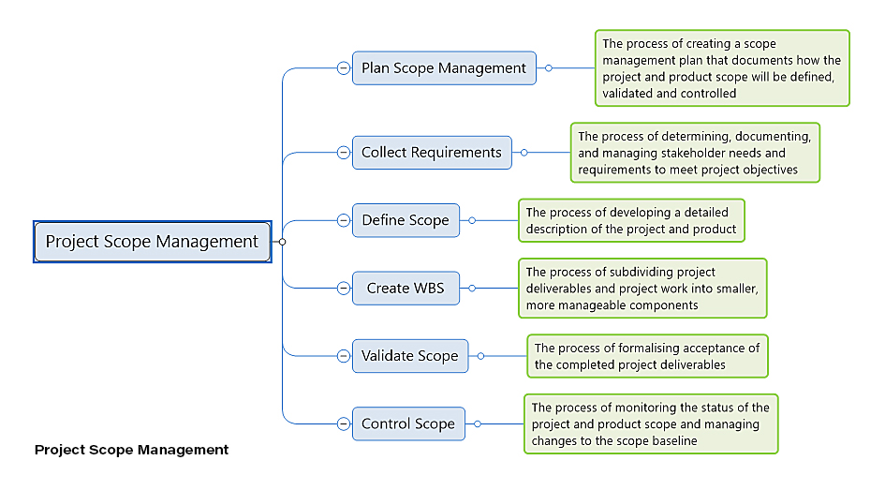

## **Determine your project scope statement**

The scope statement is where you will identify the work that needs to be done in order to complete the project. It defines your objectives and directs the processes for completing the project. You may also see the scope statement referred to as “the statement of work” or “term of reference.”

Having a clear scope statement will ensure that everyone knows what to expect, that each required step is taken, and that the project is successfully completed on time and on budget.

The scope statement should include a list of everything needed to create the framework for the project including: project goals, deliverables, features, functions, tasks, deadlines, and costs.

The project manager, working together with the team leaders and stakeholders, should develop the scope statement, ensuring the following:

* It includes only the work (scope) required;
* Each step of the project can be completed on time, and
* That the project can be completed within the allotted budget.

### **The scope statement should include:**

1. The boundaries of the project (what is and what is not included)
2. The responsibilities of each team and the individual team members
3. The procedures for completing each step of the project
4. How each step will be verified and approved

### **Why the project scope statement is essential**

You wouldn’t go on a long road trip without a map. The project scope statement is like a map used to get from start to finish. Without this statement, team members cannot be clear on what they are supposed to do and when. You are also more likely to miss deadlines, make mistakes and run over budget.

The scope statement also becomes part of your essential documentation, proving that all parties were informed and signed off on the project before any work began. You need such a statement to protect your interests in the event of disputes with the client, contractors, sub-contractors or workers.

### **Here is an example of a project scope statement:**

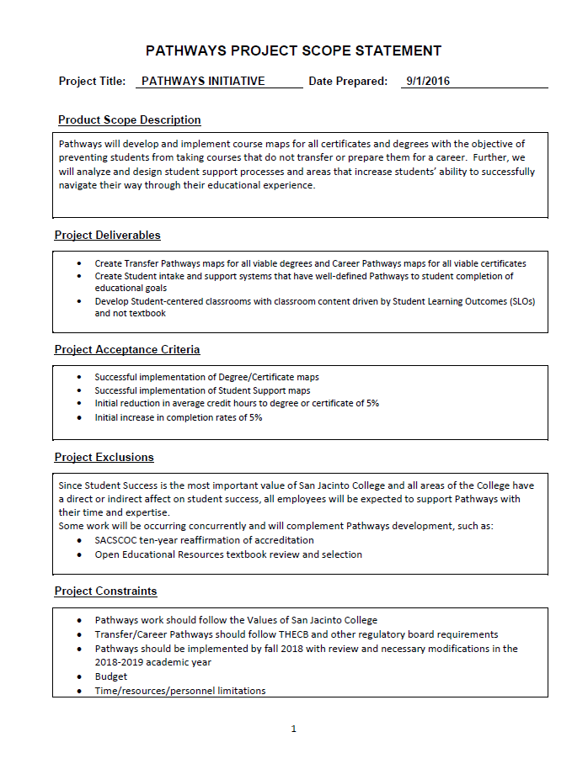

## **Project management steps**

Project scope management requires a number of steps to ensure the correct processes are put in place. In general, there are 6 steps, which can be applied to nearly any industry or type of project, whether it’s a new product, computer network system, computer software/hardware, engineering project, construction project, or a new department within an organization.

### **1. Plan Scope Management**

This first step involves planning the process and creating a scope management plan. The goal of this step is to determine how the scope will be defined, managed, verified and controlled.

There are 4 primary parts of the scope management plan:

* Requirements
* Scope Statement
* Work Breakdown Schedule
* WBS (work breakdown structure) Dictionary

### **2. Collect Requirements**

This second step will establish what needs to be accomplished during the project. You will need to collect the requirements of all the stakeholders, which may include the client, senior management, investors, government regulators, neighbors or nearby landowners. You will determine the project timeline, allocation of resources, and set the goals of the project.

There are 5 categories of project requirements:

* Business requirements
* Stakeholder requirements
* Product requirements
* Transition requirements
* Quality requirements

### **3. Define Scope**

This step involves determining the scope of the work that will be involved in order to deliver the project. It should outline the steps that will be taken in order to meet the project’s goals and objectives.

Define the project scope by identifying:

* Project objectives
* Goals
* Sub-phases
* Tasks
* Resources
* Budget
* Schedule

In this phase you will also establish the parameters of the project. In other words, you must define exactly what is included in the project and what is not. This ensures that the client, stakeholders, senior management, project manager, and team members are all aware of what is expected.

### **4. Create WBS**

The Work Breakdown Structure (WBS) involves subdividing the project deliverables into smaller units. Basically, you break down the project into phases, including the tasks required in order to complete each phase.

If you were building a house, the WBS phases might include:

* Design – Creating plans/blueprints and making changes to the plans
* Structural – Excavation, pouring foundation, framing, drywalling and roof joists
* Utilities – Plumbing, electrical and HVAC
* Finishing – Painting, windows, roofing, siding and landscaping

A WBS Example:

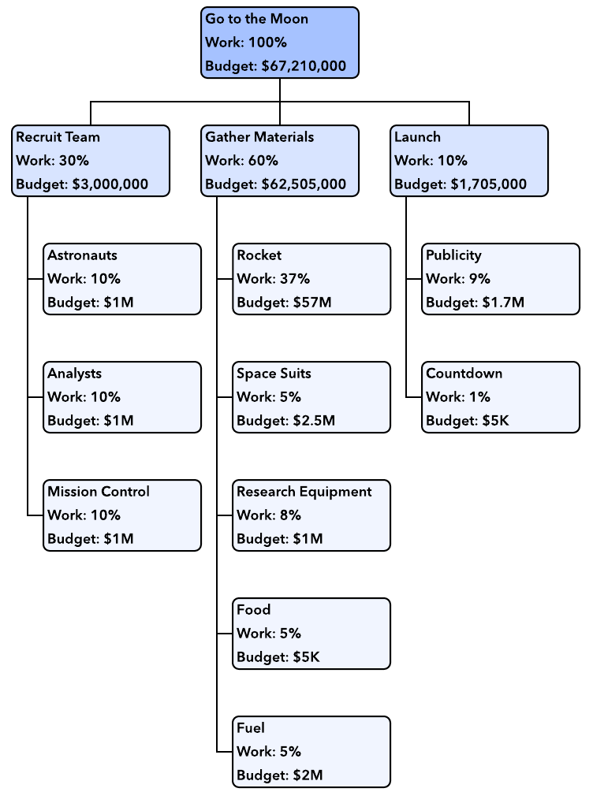

### **5. Validate Scope**

This step has to do with formalizing the acceptance of deliverables. This phase is not concerned with the deliverables themselves, but how they will be accepted and approved. The point of this phase is to avoid stakeholders deciding that things should have been done differently after the project has been completed.

Validate Scope should include:

* Whether the project deliverables are accepted?
* Who accepts project deliverables?
* Under what conditions deliverables will be accepted?

### **6. Control Scope**

This refers to the process of monitoring progress and managing changes that come up during the project. It monitors “scope creep,” which happens when additional tasks are added/changed, without making the necessary changes to the scope in terms of schedule, costs and resources. This is an essential part of the process as changes can result in lost time, cost overruns, and will require the reallocation of assets and manpower.

## **10 Tips For Successful Project Planning and Management**

Planning any project requires sound project scope management. You must have a clear plan so that all parties involved know what to expect and what their roles will be.

**Here are 10 final tips to have successful project scope management:**

1. **Understand the project** – You must identify and understand the interests, needs, and goals of the client and have a firm grasp on the objectives of the project.
2. **Identify the project requirements** – In order to know what resources are needed, you must identify the requirements to complete the project. You will then need to assemble a team, define roles and allocate tasks.
3. **Hire a qualified project manager** – The best plan in the world will fall apart if you do not have the right project manager. They should be adept at managing a team, with a clear understanding of how to allocate tasks based on the skills and personalities of each person.
4. **Define milestones** – In order to complete a project, you must define key phases of a project or milestone. You must also define how to evaluate and approve each phase/milestone.
5. **Maintain communications** – You must be able to communicate with the stakeholders, the project manager, supervisors, contractors, and team members to discuss issues and changes so that everyone remains on the same page.
6. **Identify team members’ strengths and weaknesses** – Being aware of the strengths and weaknesses of team members will make the team more efficient so you can meet the project requirements.
7. **Take advantage of management tools** – There are many resources in online project management software. These tools can be a centralized platform to track, manage, share, and communicate with everyone involved in the project.
8. **Practice risk management** – Managing potential risks is essential in order to identify potential threats, and avoid mistakes and cost overruns that could derail a project.
9. **Test deliverables** – In order to deliver a project successfully, you need to develop tests at critical milestones. This will ensure the requirements of each step have been met.
10. **Evaluation of the project** – After a project is complete, the project manager should review and evaluate the various components of the project and the project as a whole. The objective is to identify successes as well as areas where improvements can be made to prevent mistakes on future projects.

## Why is a Project Scope Statement Important?

According to the [Project Management Institute](https://www.pmi.org/learning/library/project-scope-statement-skills-tools-7981), a strong project scope statement has several key characteristics. It should:

* Define the boundaries of the project.
* Define the business need and the expected outcome of the project.
* Identify constraints that limit a project team’s options for developing a solution.
* List assumptions regarding decisions outside the project team’s control.
* Identify business processes impacted by the project.
* Identify internal and external entities with which the project team will interface.

“The project scope statement tries to reduce uncertainty by defining the scope and ensuring all key stakeholders are on board and have a clear understanding of the project,” Alexis says. “If you have a strong process, there will be fewer change requests. If you can do that, then you have a better chance of success.”

As with all project management documents, Alexis adds, the project scope statement may have a consistent format from one project to another, but it should also be customizable depending on the size, scale, and complexity of the project. These factors will also impact the types of stakeholders who must be involved in both developing and receiving the project scope statement.

## How Is a Project Scope Statement Different from other Project Management Documents?

While a project scope statement is critical to the success of a project, certain components of the project are covered in different documents. Here are two important examples.

***Product scope statement.*** Just as there are subtle differences in the [roles of a product manager and project manager](https://www.northeastern.edu/graduate/blog/project-manager-vs-product-manager/), there are some differences between project scope and product scope. A product scope includes additional information about the features and functions of the product, service, or solution that a project will deliver. A project scope will state, “Ship a new tablet PC by the end of 2020,” but the product scope will provide details about screen size, type of processor, amount of memory, and so on.

***Project master plan.*** If the project scope statement is the foundation upon which the project is built, then the project master plan is the rest of the building. The project master plan provides a detailed project schedule and work structure as well as plans and procedures for risk management, quality management, and communications management, Alexis says. Successful execution of the project master plan, however, depends on the strength of your project scope statement, he adds.

## 8 Key Steps to Developing a Project Scope Statement

Alexis has nearly two decades of experience managing major programs and projects within the manufacturing and power generation industries, with current work focusing on sustainability initiatives. Based on his experience, he recommends project managers follow the eight steps below steps to develop an effective project scope statement.

### **1. Understand why the project was initiated.**

Projects are not carried out in a vacuum, Alexis says; they are initiated to meet specific goals for an organization. For example, an organization may be looking to reduce operating costs by five percent by the end of next year, improve efficiency by 10 percent, or increase headcount by 20 percent. “As much as possible, the goals of the organization should be expressed in the project scope statement,” Alexis notes.

### **2. Define the key objectives of the project.**

Once project managers understand what the organization is trying to achieve, they need to define the objectives of the specific project. The objectives should note why the project is being done, what will be done, when it will be done, and how much it will cost. In other words, the objectives describe why executives selected and funded a project and justify why the project exists, Alexis says. Objectives should be written with the [SMART goal-setting best practices](https://blog.capterra.com/10-smart-goal-setting-best-practices-for-project-planning/) in mind—meaning they should be specific, measurable, achievable, relevant, and time-bound.

### **3. Outline the project statement of work.**

The statement of work provides a detailed breakdown of the work that a project team will perform. For a project focused on creating an internal review of new markets to enter, for example, items in the scope of work might include identifying and prioritizing targets, analyzing the benefits and drawbacks of each potential target, assessing the steps the company must take to enter each market, and providing guidance and recommendations for key decision-makers.

### **4. Identify major deliverables.**

Project managers should work alongside key stakeholders to list the items that will be delivered at the end of the project, Alexis says. In the project scope statement, these items can be described at a high level—a new market assessment report, for example, or a new software feature—but they should still be tangible and measurable targets. A separate document, the work detail structure, will outline the specific activities associated with a particular deliverable. One way to remember the difference, according to Alexis: Deliverables are usually expressed as nouns and adjectives, while work details are expressed as verbs.

### **5. Select key milestones.**

A key milestone indicates when stakeholders can expect a particular deliverable to be completed. More complex projects may also include milestones for specific steps involved in creating or completing a deliverable. Milestones must include a specific date, Alexis says—not just that a report will be finished, but that it will be finished by October 15, 2020, for example.

### **6. Identify major constraints.**

The project scope statement should note any limitations that the project team will face as it works to complete a project. These constraints could include personnel, resources, schedule, or other requirements.

### **7. List scope exclusions.**

This list consists of deliverables that a project sponsor may assume are included in the scope of the project but are not, in fact, included. For example, a project sponsor may assume that a project to develop a management system also includes certification of that system. The project scope statement should clearly indicate if the project team will get the system certified or if the sponsor is responsible for obtaining certification after the project has been completed. This clarity helps project managers avoid “scope creep,” which occurs when deliverables that were not part of the original scope statement are added to a project mid-stream.

### **8. Obtain sign-off.**

Requiring key stakeholders to sign the project scope statement offers confirmation that they are aware of and understand the contents of the scope, Alexis says. This helps avoid miscommunication that can lead to rework during or after the project—ultimately saving project managers and organizations frustration, time, and money.

# Top 11 Project Selection Methods for Project Managers

When you have a number of interesting and challenging [projects](https://www.simplilearn.com/what-is-a-project-article) to choose from, finding a project that is the right fit for your team’s skill set, level of competence, and has the best chance of success is the first step in effective [project management.](https://www.simplilearn.com/tips-on-project-management-article) Project Selection Methods offer a set of time-tested techniques based on sound logical reasoning to choose a project and filter out undesirable projects with a very low likelihood of success. Project selection methods are an important concept for practicing [project managers](https://www.simplilearn.com/program-manager-vs-project-manager-article) and aspirants preparing for the [PMP](https://www.simplilearn.com/project-management/pmp-certification-training)® exam alike. And in this article, we will discuss the following project selection methods in detail:

1. Benefit measurement methods
2. Benefit/cost ratio
3. Economic model
4. Scoring model
5. Payback period
6. Net present value
7. Discounted cash flow
8. Internal rate of return
9. Opportunity cost
10. Constrained optimization methods
11. Non-financial considerations

## **What are Project Selection Methods?**

Consider this scenario: the organization you are working for has been handed a number of project contracts. Due to resource constraints, the organization can’t handle all the projects at once, so they need to decide which project(s) will maximize profitability.

This is where [project selection methods](https://www.simplilearn.com/preparation-project-selection-methods-article) come into play. There are two categories of project selection methods:

* Benefit Measurement Methods
* Constrained Optimization Methods

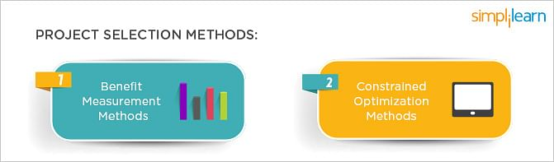

Although time-consuming, employing these methods is essential for an effective business plan. There are a variety of documented methods for selecting a project, but the basic thumb rule is: for small projects that aren’t very complex, the Benefit Measurement Model is useful, whereas if it’s a large, complex project, the Constrained Optimization Method is a better fit. Let’s take a look at both these methods in further detail.

## **Various Project Selection Methods**

### **1. Benefit Measurement Methods**

Benefit Measurement is a project selection technique based on the present value of estimated cash outflow and inflow. Cost benefits are calculated and then compared to other projects to make a decision. The techniques that are used in Benefit Measurement are as follows:

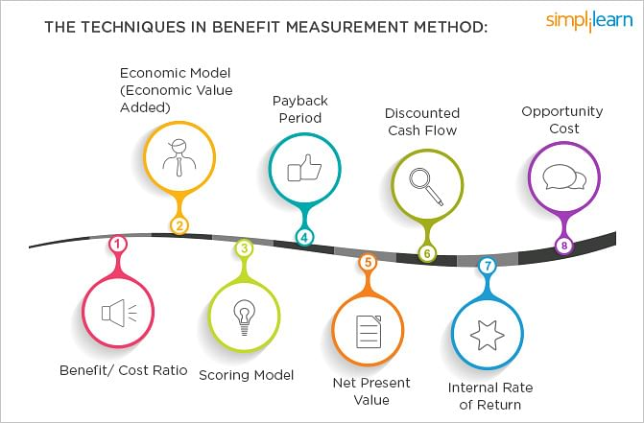

### **2. Benefit/Cost Ratio**

Cost/Benefit Ratio, as the name suggests, is the ratio between the Present Value of Inflow or the cost invested in a project to the Present Value of Outflow, which is the value of return from the project. Projects that have a higher Benefit-Cost Ratio or lower Cost-Benefit Ratio are generally chosen over others.

### **3. Economic Model**

EVA, or [Economic Value Added](https://en.wikipedia.org/wiki/Economic_value_added), is the performance metric that calculates the worth-creation of the organization while defining the return on capital. It is also defined as the net profit after the deduction of taxes and capital expenditure.

If there are several projects assigned to a project manager, the project that has the highest Economic Value Added is picked. The EVA is always expressed in numerical terms and not as a percentage.

### **4. Scoring Model in Project Management**

The scoring model in project management is an objective technique: the project selection committee lists relevant criteria, weighs them according to their importance and their priorities, then adds the weighted values. Once the scoring of these projects is completed, the project with the highest score is chosen.

### **5. Payback Period**

[Payback Period](https://en.wikipedia.org/wiki/Payback_period) is the ratio of the total cash to the average per period cash. It is the time necessary to recover the cost invested in the project. The Payback Period is a basic project selection method. As the name suggests, the payback period takes into consideration the payback period of an investment.  It is the time frame that is required for the return on an investment to repay the original cost that was invested. The calculation for payback is fairly simple:

When the Payback period is used as the Project Selection Method, the project that has the shortest Payback period is preferred since the organization can regain the original investment faster. There are, however, a few limitations to this method:

* It does not consider the time value of money.
* Benefits accrued after the payback period are not considered; it focuses more on the liquidity while profitability is neglected.
* Risks involved in individual projects are neglected.

### **6. Net Present Value**

Net Present Value is the difference between the project’s current value of cash inflow and the current value of cash outflow. The NPV must always be positive. When picking a project, one with a higher NPV is preferred. The advantage of considering the NPV over the Payback Period is that it takes into consideration the future value of money. However, there are limitations of the NPV, too:

* There isn’t any generally accepted method of deriving the discount value used for the present value calculation.
* The NPV does not provide any picture of profit or loss that the organization can make by embarking on a certain project.
* For more details on the NPV and how to use the NPV as a tool to filter [projects](https://www.simplilearn.com/simplilearn.com/how-to-make-a-project-successful-article) out, here’s an insightful article on calculating the [opportunity costs for projects](https://www.simplilearn.com/opportunity-costs-management-article).

### **7. Discounted Cash Flow**

It’s well-known that the future value of money will not be the same as it is today. For example, $20,000 won’t have the same worth ten years from now. Therefore, during calculations of cost investment and [ROI](https://en.wikipedia.org/wiki/Return_on_investment), be sure to consider the concept of discounted cash flow.

### **8. Internal Rate Of Return**

The Internal Rate of Return is the interest rate at which the Net Present Value is zero—attained when the present value of outflow is equal to the present value of inflow. Internal Rate of Return is defined as the “annualized effective compounded return rate” or the “discount rate that makes the net present value of all cash flows (both positive and negative) from a particular investment equal to zero.” The IRR is used to select the project with the best profitability; when picking a project, the one with the higher IRR is chosen.

When using the IRR as the project selection criteria, organizations should remember not to use this exclusively to judge the worth of a project; a project with a lower IRR might have a higher NPV and, assuming there is no capital constraint, the project with the higher NPV should be chosen as this increases the [shareholders](https://www.simplilearn.com/stakeholders-impact-on-the-projects-article)’ profits.

### **9. Opportunity Cost**

Opportunity Cost is the cost that is given up when selecting another project. During project selection, the project that has the lower opportunity cost is chosen.

### **10. Constrained Optimization Methods**

Constrained Optimization Methods, also known as the Mathematical Model of Project Selection, are used for larger projects that require complex and comprehensive mathematical calculations. The techniques that are used in Constrained Optimization Methods are as follows:

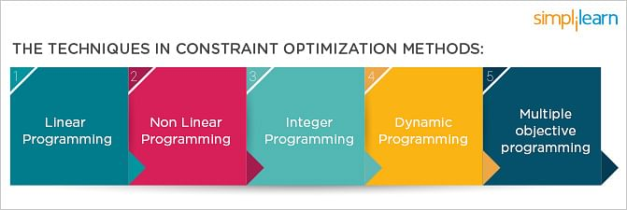

These topics, however, are not discussed in detail in the [PMP® certification](https://www.simplilearn.com/project-management/pmp-certification-training). For the exam, all that is necessary to know is that this is the list of Mathematical Model techniques that are used in Project Selection.

### **11. Non-Financial Considerations**

There are non-financial gains that an organization must consider; these factors are related to the overall organizational goals. The organizational strategy is a major factor in project selection methods that will affect the organization’s choice in the choice of project. Customer service relationships are chief among these organizational goals. An important necessity in today’s business world is to build effective, cordial customer relationships.

# Project Selection Methods

## **Introduction**

One of the biggest decisions that any organization would have to make is related to the projects they would undertake. Once a proposal has been received, there are numerous factors that need to be considered before an organization decides to take it up.

The most viable option needs to be chosen, keeping in mind the goals and requirements of the organization. How is it then that you decide whether a project is viable? How do you decide if the project at hand is worth approving? This is where project selection methods come in use.

Choosing a project using the right method is therefore of utmost importance. This is what will ultimately define the way the project is to be carried out.

But the question then arises as to how you would go about finding the right methodology for your particular organization. At this instance, you would need careful guidance in the project selection criteria, as a small mistake could be detrimental to your project as a whole, and in the long run, the organization as well.

## **Selection Methods**

There are various project selection methods practised by the modern business organizations. These methods have different features and characteristics. Therefore, each selection method is best for different organizations.

Although there are many differences between these project selection methods, usually the underlying concepts and principles are the same.

Following is an illustration of two of such methods (Benefit Measurement and Constrained Optimization methods):

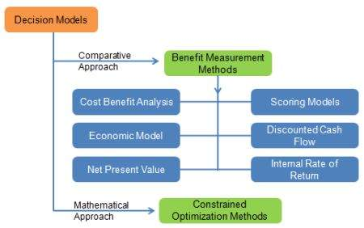

As the value of one project would need to be compared against the other projects, you could use the benefit measurement methods. This could include various techniques, of which the following are the most common:

* You and your team could come up with certain criteria that you want your ideal project objectives to meet. You could then give each project scores based on how they rate in each of these criteria and then choose the project with the highest score.
* When it comes to the Discounted Cash flow method, the future value of a project is ascertained by considering the present value and the interest earned on the money. The higher the present value of the project, the better it would be for your organization.
* The rate of return received from the money is what is known as the IRR. Here again, you need to be looking for a high rate of return from the project.

The mathematical approach is commonly used for larger projects. The constrained optimization methods require several calculations in order to decide on whether or not a project should be rejected.

Cost-benefit analysis is used by several organizations to assist them to make their selections. Going by this method, you would have to consider all the positive aspects of the project which are the benefits and then deduct the negative aspects (or the costs) from the benefits. Based on the results you receive for different projects, you could choose which option would be the most viable and financially rewarding.

These benefits and costs need to be carefully considered and quantified in order to arrive at a proper conclusion. Questions that you may want to consider asking in the selection process are:

* Would this decision help me to increase organizational value in the long run?
* How long will the equipment last for?
* Would I be able to cut down on costs as I go along?

In addition to these methods, you could also consider choosing based on opportunity cost - When choosing any project, you would need to keep in mind the profits that you would make if you decide to go ahead with the project.

Profit optimization is therefore the ultimate goal. You need to consider the difference between the profits of the project you are primarily interested in and the next best alternative.

## **Implementation of the Chosen Method**

The methods mentioned above can be carried out in various combinations. It is best that you try out different methods, as in this way you would be able to make the best decision for your organization considering a wide range of factors rather than concentrating on just a few. Careful consideration would therefore need to be given to each project.

## **Conclusion**

In conclusion, you would need to remember that these methods are time-consuming, but are absolutely essential for efficient business planning.

It is always best to have a good plan from the inception, with a list of criteria to be considered and goals to be achieved. This will guide you through the entire selection process and will also ensure that you do make the right choice.

# 13 Top Project Selection Methods

It requires strong leadership, superior communication abilities, meticulous planning, and a number of other [essential characteristics](https://www.4pmti.com/blog/skills-effective-project-management/) as well.

But there’s one skill that doesn’t get enough emphasis in the world of project management – strategic and effectual Project Selection.

In fact, a recent Six Sigma-focused study of 43 different companies found that an [astounding 75%](http://www.ssqi.com/breakthroughs/whitepaper-pdfs/Project_selection_WP.pdf)didn’t even follow the project selection methods.

“Ultimately,” writes Six Sigma Qualtec, “if you don’t have a Project Selection process in place – one that is rigorously followed – you will falter.”

An informed and experienced approach to Project Selection allows your company to more effectively manage prospective projects, identify key efforts with more substantial ROIs, and leverage the skills already in place to select projects well-suited for your company’s particular competencies.

In most cases, the final decision on which proposals are accepted generally will fall to executive leadership rather than project managers (PMs).

However, a good project manager should be able to use their experience to help guide decision makers towards choosing an ideal project while still keeping risk and cost estimates realistic.

## Project Selection MethodsImportance of Project Selection Methods

Before jumping into an examination of the two main methods of Project Selection as well as their various techniques, it’s important to first understand just why Project Selection is so important for your business.

In addition to using the right [project management methodology](https://www.4pmti.com/blog/project-management-methodologies/) for your company, selecting the right projects can mean the difference between one year in the black or several in the red. An unreasonable project scope, loosely defined deliverables, and unrealistic goals can all lead to an enormous drain on your budget and critically damage productivity as well.

But picking the right projects isn’t as easy as just trusting your gut.

Instead, selecting the right project for your company’s skills and available resources requires a bit of pretty important calculation on your part. These calculations can be done in two different ways: using the Benefit Measurement Methods or the Constrained Optimization Methods.

## Project Selection MethodsMethod #1: Benefit Measurement Methods

The Benefit Measurement Methods are likely going to be the only methods you’ll be using directly as a project manager. While less complex than the Constrained Optimization Methods, they often don’t require an advanced degree in finance to be able to understand them.

They’re great for smaller projects that aren’t especially complicated.

Benefit Measurement Methods, as the name suggests, rate potential projects according to a specific model and compare those results between the project candidates. Below are the most common Benefit Measurement Methods you’ll be using as a PM.

### **1.**Cost Benefit**Ratio**

The simplest of the Benefit Measurement Methods, the cost benefit ratio is an effective way of communicating the potential value of a project in easily understandable terms. It measures the costs of investing in a project against the value of the return once it is completed.

A project that requires $280,000 in resources to complete with an expected $420,000 return would have a 4:6 (or 2:3) cost benefit ratio. Essentially, every $2 invested in this project would yield $3 in revenue. Projects with a lower cost benefit ratio (or a higher benefit cost ratio) should be selected if evaluated only by this method.

### **2. Economic Model**

The Economic Model, also known as the Economic Value Added (EVA), is similar to the Cost Benefit Ratio technique in that it describes the difference between costs invested and revenue generated in one number – profit.

Investopedia aptly [defines EVA](https://www.investopedia.com/ask/answers/032715/whats-difference-between-economic-value-added-eva-and-accounting-profit.asp) as “net operating profit after tax – (invested capital X weighted average cost of capital).” This model provides a clear representation of the quantifiable benefits of a project once it’s completed and can help give you a solid idea of what kinds of returns to expect for each project.

### **3. Payback Period**

The Payback Period Technique takes a look at how long it will take your company to recoup its expenses with a particular project. If our $280,000 project were to bring in $20,000 a year once it’s completed, the total payback period would be 14 years.

It’s worth remembering though, that any time you try to factor in returns over time you should be looking at the present dollar value of the future revenue as inflation and interest will all come into play.

### **4. Discounted Cash Flow (DCF)**

The Discounted Cash Flow Analysis handles the problem of calculating the present value of future earned dollars. This is one of the best ways to calculate value of returns that occur over a long period of time rather than immediately after completion.

While the Payback Period Model is easy to calculate and simple to understand, the Discounted Cash Flow (DCF) model incorporates the time value of money. This concept helps translate future earnings into present day dollar values since a dollar in hand has more earning potential than one promised for later.

### **5. Net Present Value (NPV)**

Using Discounted Cash Flow, the Net Present Value (NPV) model helps put the whole lifecycle of the project into perspective in terms of earnings.

For instance, calculating the earnings for year one of the project may return a net loss of, say, $800. Year two may see a loss of $200, while years three, four, and five may result in gains of $500, $1000, and $1500. All of these values would of course be informed by the DCF concept to translate future values into present dollars.

The Net Present Value of the project, then, would be the combination of all of these numbers ($3000 minus losses of $1000) and would equal $2000.

While there are a number of essential [free tools](https://www.4pmti.com/blog/free-project-management-software/) at a project manager’s disposal in general, the easiest one for calculating NPV is Excel by far.

For help in determining how to calculate NPV using Excel, head over to [Microsoft’s help page](https://support.office.com/en-us/article/NPV-function-8672cb67-2576-4d07-b67b-ac28acf2a568) dedicated to the subject.

The equation for determining Net Present Value according to [Finance Formulas](http://financeformulas.net/Net_Present_Value.html) is:

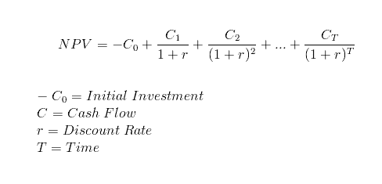

### **6. Scoring Models**

Scoring Models may be the most flexible way of comparing projects to one another. Rather than focusing purely on financials, Scoring Models let you determine which qualities of a project are most important to you, your team, and your company at large.

You may, for example, choose to look at profitability, [overall risk](https://www.4pmti.com/blog/risk-example-in-dollars-and-sense/), support from stakeholders, and difficulty of the project.

Once the criteria are chosen, you’ll want to weight them according to your priorities and rank each project in terms of these four measures using a consistent scale. The total numbers for a single project are then combined and used to reflect the project’s total value, making it easy to compare your projects to one another.

### **7. Internal Rate of Return (IRR)**

The Internal Rate of Return (IRR) incorporates the Net Present Value into its calculation by setting the NPV to zero. Essentially, this means that all cash flow from a project (both negative and positive) even each other out.

Using the same equation as NPV where the NPV is set to zero, the IRR of a project is determined by solving for the variable “r” rather than NPV. If the Internal Rate of Return for a project is lower than the company’s required rate of return (RRR), then that project can be eliminated entirely.

### **8. Opportunity Cost**

The concept of opportunity cost is crucial to understand for any [certified project manager](https://www.4pmti.com/blog/become-a-certified-project-manager/) worth their salt. Essentially, Opportunity Cost comes down to what you’re missing out on by choosing one project over another.

More a supplemental technique than a standalone method itself, Opportunity Cost can be a great way to put a certain project choice into perspective. If, for example, Project 1 and Project 2 are worth $75,000 and $85,000 respectively, going with Project 1 would have an opportunity cost of $10,000 since that’s how much your company would miss out on.

## Project Selection MethodsMethod #2: Constrained Optimization Methods

While the Benefit Measurement Methods are generally the most widely used Project Selection methods for project managers, Constrained Optimization Methods may also come into play. These methods are great for larger, more complex projects where a number of intricate mathematical calculations will need to be performed.

In fact, the Constrained Optimization Methods are also known as the Mathematical Model of Project Selection.

Given their complexity though, many project managers will likely choose the Benefit Measurement methods to meet their Project Selection needs. What’s more, the Constrained Optimization Methods are not covered in-depth in the [PMP certification](https://www.4pmti.com/blog/reasons-to-take-pmp-certification/) exam but are provided here for supplementary purposes only.

For more information on the methods below, [Testing Brain](http://www.testingbrain.com/project-management/constrained-optimization-methods-of-project-selection.html) provides quite a comprehensive look at each.

**1. Linear Programming**  
This programming method involves bringing down the cost of the project through reduction of the time required to complete it.

**2. Nonlinear Programming**  
Nonlinear Programming aims at solving optimization problems within projects wherein some of the constraints or functions are nonlinear.

**3. Integer Programming**  
This method focuses on integer values rather than fractional ones. Some products, like tables for example, can never be fractional.

**4. Dynamic Programming**  
This method involves simplifying a complex problem by separating it into a number of simpler problems.

**5. Multiple Objective Programming**  
The Multiple Objective Programming approach focuses on making a decision for a number of problems using mathematical optimization.

## Project Selection MethodsProject Selection: A Variety of Tools at Your Disposal

As a project manager, you’ll undoubtedly have the opportunity to influence key decision makers when it comes to project selection. Your expertise, institutional knowledge, and skills in the field can in fact be instrumental in ensuring your company picks out only the most promising of projects.

And with the variety of Project Selection methods and tools to choose from, you can be sure you’ve made the right choice each time.

# Work Breakdown Structure (WBS)

* [What Is a Work Breakdown Structure (WBS)?](https://www.projectmanager.com/work-breakdown-structure#section1)
* [Why Use a WBS In Project Management?](https://www.projectmanager.com/work-breakdown-structure#section2)
* [Work Breakdown Structure Example](https://www.projectmanager.com/work-breakdown-structure#section3)
* [Types of WBS](https://www.projectmanager.com/work-breakdown-structure#section4)
* [WBS Elements](https://www.projectmanager.com/work-breakdown-structure#section6)
* [How to Create a Work Breakdown Structure In Six Steps](https://www.projectmanager.com/work-breakdown-structure#section7)
* [WBS Software](https://www.projectmanager.com/work-breakdown-structure#section8)
* [Must-Have Features of WBS Software](https://www.projectmanager.com/work-breakdown-structure#section-tabs)
* [How to Create a WBS in ProjectManager](https://www.projectmanager.com/work-breakdown-structure#section10)
* [Work Breakdown Structure Template](https://www.projectmanager.com/work-breakdown-structure#section11)
* [Work Breakdown Structure Best Practices](https://www.projectmanager.com/work-breakdown-structure#section12)

## What Is a Work Breakdown Structure (WBS)?

**A work breakdown structure (WBS) is a visual, hierarchical and deliverable-oriented deconstruction of a project.** It is a helpful diagram for project managers because it allows them to break down their project scope and visualize all the tasks required to complete their projects.

All the steps of project work are outlined in the work breakdown structure chart, which makes it an essential project planning tool. Project managers use a WBS for many purposes, such as finding the [critical path](https://www.projectmanager.com/critical-path-method) or creating a Gantt chart.

Project managers make use of project management software to lay out and execute a work breakdown structure. When used in combination with a [Gantt](https://www.projectmanager.com/gantt-chart) chart that incorporates WBS levels and task hierarchies, project management software can be especially effective for planning, scheduling and executing projects.

[ProjectManager](https://www.projectmanager.com/) is an online work management software with industry-leading project management tools like Gantt charts, kanban boards, sheets and more. Plan using WBS levels in our tool, then execute with your team via easy-to-use kanban boards and task lists. Try it for free today.

## Why Use a WBS In Project Management?

Making a WBS is the first step in developing a [project schedule](https://www.projectmanager.com/project-scheduling). It defines all the work that needs to be completed (and in what order) to achieve the project goals and objectives. By visualizing your project in this manner, you can understand your project scope, and allocate resources for all your project tasks.

A well-constructed work breakdown structure helps with important [project management process groups](https://www.projectmanager.com/blog/project-management-process-groups) and knowledge areas such as:

Project Planning, Project Scheduling and Project Budgeting

Risk Management, Resource Management, Task Management and Team Management

In addition, a WBS helps avoid common [project management](https://www.projectmanager.com/project-management) issues such as missed deadlines, scope creep and cost overrun, among others.

In other words, a work breakdown structure serves as your map through complicated projects. Your [project scope](https://www.projectmanager.com/blog/project-scope) may include several phases, or smaller sub-projects—and even those sub-projects can be broken down into tasks, deliverables, and work packages! Your WBS can help you manage those items, and gain clarity into the details needed to accomplish every aspect of your project scope.

## Work Breakdown Structure Example

Now that we’ve gone through the definition of a WBS and learned why they are a great project management tool, let’s take a look at a work breakdown structure example.

The final project deliverable, as well as the tasks and work packages associated with it rest on top of the WBS diagram, and the WBS levels below subdivide the project scope to indicate the tasks, deliverables and work packages that are needed to complete the project from start to finish.

For our WBS example, we’ll be creating a work breakdown structure to guide a commercial building construction project. This is potentially a complex project, but a WBS chart will take that complexity and boil the project scope down to simpler tasks to make the project manageable.

Study the phase-based work breakdown structure example of a construction project below:

At the top of the work breakdown structure is your final deliverable (in this instance, the construction project). Immediately beneath that is the next WBS level, which are the main project phases required to complete the project. The third and lowest level shows [work packages](https://www.projectmanager.com/blog/work-package-in-project-management). Most WBS charts have 3 levels, but you can add more depending on the complexity of your projects.

Each of those five project phases—initiation, planning, execution, control and closeout, also act as control accounts and branch off the main deliverable at the top. Once decided, they are then broken down into a series of deliverables. For example, the [initiation phase](https://www.projectmanager.com/blog/project-initiation) includes site evaluation work and creating the project charter.

You’ll also need a work package to go with each of those project deliverables. In the execution phase in our construction example, we can look at the interior work deliverable. That deliverable is divided into two work packages, which are installing the plumbing and setting up the electricity.

The WBS, when created as thoroughly as possible, is the roadmap to guide you to completion of what would seem to be a very complicated project scope. However, when broken down with a WBS, project planning, scheduling and resource planning suddenly become much more manageable.

## Types of WBS

There are two main types of WBS: deliverable-based, and phase-based. They depend on whether you want to divide your project in terms of time or scope.

### Deliverable-Based Work Breakdown Structure

A deliverable-based WBS first breaks down the project into all the major areas of the project scope as control accounts, and then divides those into project deliverables and work packages.

Here’s an example of a deliverable-based WBS that’s taken from our [free work breakdown structure template.](https://www.projectmanager.com/templates/work-breakdown-structure-template) Download the template today to practice building your own work breakdown structure in Excel.

An deliverable-based WBS example showing control accounts, work packages and tasks.

### Phase-Based Work Breakdown Structure

The phase-based WBS displays the final deliverable on top, with the WBS levels below showing the five phases of a project (initiation, planning, execution, control and closeout). Just as in the deliverable-based WBS, the project phases are divided into project deliverables and work packages. Our previous graphic in the “Work Breakdown Structure Example” section contained a phase-based WBS example.

## Types of WBS Charts

Once you’ve chosen a deliverable-based or phase-based WBS, you can also choose between different types of WBS diagrams. Let’s take a look at the main types of work breakdown structure charts.

**Work Breakdown Structure List:** Also known as an outline view, this is a list of work packages, tasks and deliverables. It’s probably the simplest method to make a WBS, which is sometimes all you need.

**Work Breakdown Structure Tree Diagram:** The most commonly seen version, the tree structure depiction of a WBS is an organizational chart that has all the same WBS elements of the list (phases, deliverables, tasks and work packages) but represents the workflow or progress as defined by a diagrammatic representation.

**Work Breakdown Structure Gantt Chart:** A [Gantt chart](https://www.projectmanager.com/software/gantt-chart) is both a spreadsheet and a timeline. The Gantt chart is a WBS that can do more than a static task list or tree diagram. With a dynamic Gantt chart, you can link dependencies, set milestones, even set a baseline. This is the most common version in project management software.

Build a work breakdown structure Gantt chart diagram in ProjectManager in just a matter of minutes. Get started for free today.

A Gantt chart with WBS codes in ProjectManager. [Learn more](https://www.projectmanager.com/software/gantt-chart)

## WBS Elements

A typical project work breakdown structure is made up of several key components. We’ll use our WBS example above to identify each of the main WBS elements.

* **WBS Dictionary:** A [WBS dictionary](https://www.projectmanager.com/blog/wbs-dictionary) is a document that defines the various WBS elements. It’s an important component of a WBS because it allows the project participants and stakeholders to understand the work breakdown structure terminology with more clarity.
* **WBS Levels:** The WBS levels are what determines the hierarchy of a WBS element. Most work breakdown structures have 3 levels that represent the project’s main deliverable, control accounts, project deliverables and work packages.
* **Control Accounts:** Control accounts are used to group work packages and measure their status. They’re used to control areas of your project scope. In our example the execution project phase could be a control account because it has several deliverables and work packages associated to it.
* **Project Deliverables:** Project deliverables are the desired outcome of project tasks and work packages. In our WBS example, we can observe some examples of project deliverables such as the project budget or interior work. Both of them are the result of smaller tasks and work packages.
* **Work Packages:** As defined by the [project management institute](https://www.pmi.org/) (PMI) in its project management body of knowledge book (PMBOK) a work package is the “lowest level of the WBS”. That’s because a work package is a group of related tasks that are small enough to be assigned to a team member or department. As a project manager you can estimate costs and duration of these work packages, which makes them an essential WBS element.
* **Tasks:** Your tasks make up your work packages and therefore, your project scope. A WBS will help you define each task requirements, status, description, task owner, dependencies, and duration.

If you prefer a visual and verbal explanation of this information on work breakdown structures, watch this video.

## How to Create a Work Breakdown Structure In Six Steps

To create a WBS for your project, you’ll need information from other project management documents. Here are six simple steps to create a work breakdown structure.

### 1. Define the Project Scope, Goals and Objectives

Your project goals and objectives set the rules for defining your project scope. Your project scope, team members, goals and objectives should be documented on your [project charter](https://www.projectmanager.com/blog/project-charter).

### 2. Identify Project Phases & Control Accounts

The next level down is the project phases: break the larger project [scope statement](https://www.projectmanager.com/blog/project-scope-statement) into a series of phases that will take it from conception to completion. You can also create control accounts, which are task categories for different work areas you want to keep track of.

### 3. List Your Project Deliverables

What are your [project deliverables](https://www.projectmanager.com/academy/project-deliverables)? List them all and note the work needed for those project deliverables to be deemed successfully delivered (sub-deliverables, work packages, resources, participants, etc.)

### 4. Set WBS Levels

The WBS levels are what make a work breakdown structure a “hierarchical deconstruction of your project scope”, as defined by the project management institute in its project management body of knowledge book (PMBOK). You’ll need to start at the final project deliverable and think about all the deliverables and work packages needed to get there from the start.

### 5. Create Work Packages

Take your deliverables from above and break them down into every single task and subtask that is necessary to deliver them. Group those into work packages.

### 6. Choose Task Owners

With the tasks now laid out, assign them to your project team. Give each team member the [work management](https://www.projectmanager.com/blog/what-is-work-management) tools, resources and authority they need to get the job done.

## WBS Software

[Work breakdown structure software](https://www.projectmanager.com/software/work-breakdown-structure) is used to outline a project’s final deliverable and define the phases that are necessary to achieve it.

Software facilitates the process in several different ways. Some use a [network diagram](https://www.projectmanager.com/blog/network-diagrams-free-tools) and others use a Gantt chart. All of them, however, are a visual representation of the project, literally breaking down the various stages and substages needed to assemble the final project deliverable.

## Must-Have Features of WBS Software

There are many types of work breakdown structure software available, so when you’re looking for one to help you plan your project, be sure it offers these features:

[**Subtasks  
Dependencies  
Project Scheduling  
Task Management  
Tracking  
Reporting**](javascript:void(0))

### Break Tasks Down

Deliverables are important to define, as are the tasks that get you there—but most tasks require being broken down further in order to complete them. That’s where subtasks come in. They’re part of a more complex task, and you want that feature in your WBS software.

## How to Create a WBS in ProjectManager

The purpose of [work breakdown structure software](https://www.projectmanager.com/software/work-breakdown-structure) in project management is to organize and define the scope of your project. Using ProjectManager’s online Gantt charts to build your WBS is not only more efficient, it dovetails into every other aspect of your project, because of our robust suite of project management features.

Here’s a quick summary of how to create a WBS using a Gantt chart. [Sign up for a free trial of our software and follow along](https://www.projectmanager.com/pricing)!

### 1. Identify Project Deliverables

There are 5 stages in the project life cycle, initiation, planning, execution, monitoring and closure. Each of them produces deliverables that are required to produce the final deliverable, which is the completion of your project.

Identify the phases in your project to create more than a mere task list. Set them apart with our [milestone](https://www.projectmanager.com/blog/milestones-project-management) feature on the Gantt chart tool. They can also be color coded to better differentiate the phases.

### 2. List Subtasks, Describe Tasks & Set Task Owner

Subtasks are part of a larger, more complex task. In this case, your WBS work packages are perfect for this feature. Add summary tasks or work packages above the related tasks, which can be your project phases or project deliverables, depending on your WBS type preference and indent them. The image below shows our WBS example represented on a Gantt chart, showing the project phases and work packages associated with them.

### 3. Link Dependencies

Task dependencies are tasks that cannot start until another is finished or started. Link tasks that are dependent on one another by dragging one to the other. We link all four types of task dependencies. By identifying these tasks at this stage, you’ll avoid bottlenecks during execution.

### 4. Set Resources & Costs

Resources are anything that you need to complete the project phases, deliverables and work packages. They range from the people on your team to materials, supplies and equipment. Your WBS allows you to break down your project scope into work packages so that you can estimate resources and costs.

### 5. Add Start & End Dates & Estimated Completion

Every task has a start and an end date. Add the date when the task needs to start in the planned start date column and when it should be completed in the planned finished date. There’s also an estimated completion column for the amount of time you plan for the task to take.

### 6. Track Status of Control Accounts & Work Packages

Tracking is how to know if a project is performing as planned. That’s why a WBS has control accounts and work packages. When speaking of tasks, tracking tells you multiple things: logged hours, costs, priority, new communications, the percentage complete and how its actual progress compares to your planned progress.

### 7. Write Notes

Having a section in which to jot down notes is always advisable. While the WBS is thorough, there might be something you need to address that doesn’t fit into its rigid structure.

### 8. Generate Reports

[Project reports](https://www.projectmanager.com/blog/4-types-of-project-reports) pull data from the project to illuminate its progress, overall health, costs and more. Generate a report on your WBS by using our reporting tool. Our reports summarize your project data and allow you to filter the results to show just want you want. Reports can also be shared with stakeholders.

## Work Breakdown Structure Template

If you’re not ready to take the plunge and use ProjectManager’s [work breakdown structure software,](https://www.projectmanager.com/software/work-breakdown-structure) but you’re still interested in seeing how using this tool can help you construct a sturdier plan for your next project, don’t worry. We have an intermediate step you can take.

We also have a library of free project management templates, including a [free WBS template](https://www.projectmanager.com/templates/work-breakdown-structure-template), to get you started off right.

If you decide to try out our project management software, we offer a free 30-day trial. You can upload the project work breakdown structure template into ProjectManager, and it automatically creates a new project in our software. Now you can use that template to plan, schedule, monitor and report on your project.

Because our software is cloud-based, all your data is collected and displayed in real time. This makes us different from on-premises project management software like [Microsoft Project](https://www.projectmanager.com/microsoft-project-alternative). We take your WBS and make it more dynamic with our [online planning tools](https://www.projectmanager.com/software/planning).

## Work Breakdown Structure Best Practices

As you’re working on your WBS it is helpful to maintain some best practices. Here are some things to keep in mind.

* **100% Rule:** This is the most important guiding principle to construct a WBS. It consists in including 100% of the work defined by the project scope, which is divided into WBS levels that contain control accounts, project deliverables, work packages and tasks. This rule applies to all the levels of the WBS, so the sum of the work at a lower WBS level must equal the 100% of the work represented by the WBS level above without exception.
* **Use Nouns:** WBS is about deliverables and the tasks that will lead to your final deliverable. Therefore, you’re dealing more on the what than the how. Verbs are great for action, and should be used in your descriptions, but for clarity, stick to nouns for each of the steps in your WBS.
* **Be Thorough:** For a WBS to do its job, there must be no holes. Everything is important if it’s part of the course that leads to your final deliverable. To manage that schedule, you need a complete listing of every task, big and small, that takes you there.
* **Keep Tasks Mutually Exclusive:** This simply means that there’s no reason to break out individual tasks for work that is already part of another task. If the work is covered in a task because it goes together with that task, then you don’t need to make it a separate task.
* **Go Just Deep Enough:** You can get crazy with subtasks on your WBS. The WBS has to be detailed, but not so deep that it becomes confusing. Ideally, think maybe three or five at most levels.

All our tools are geared to making your project more efficient and effective. See for yourself by starting your free 30-day trial of our software.